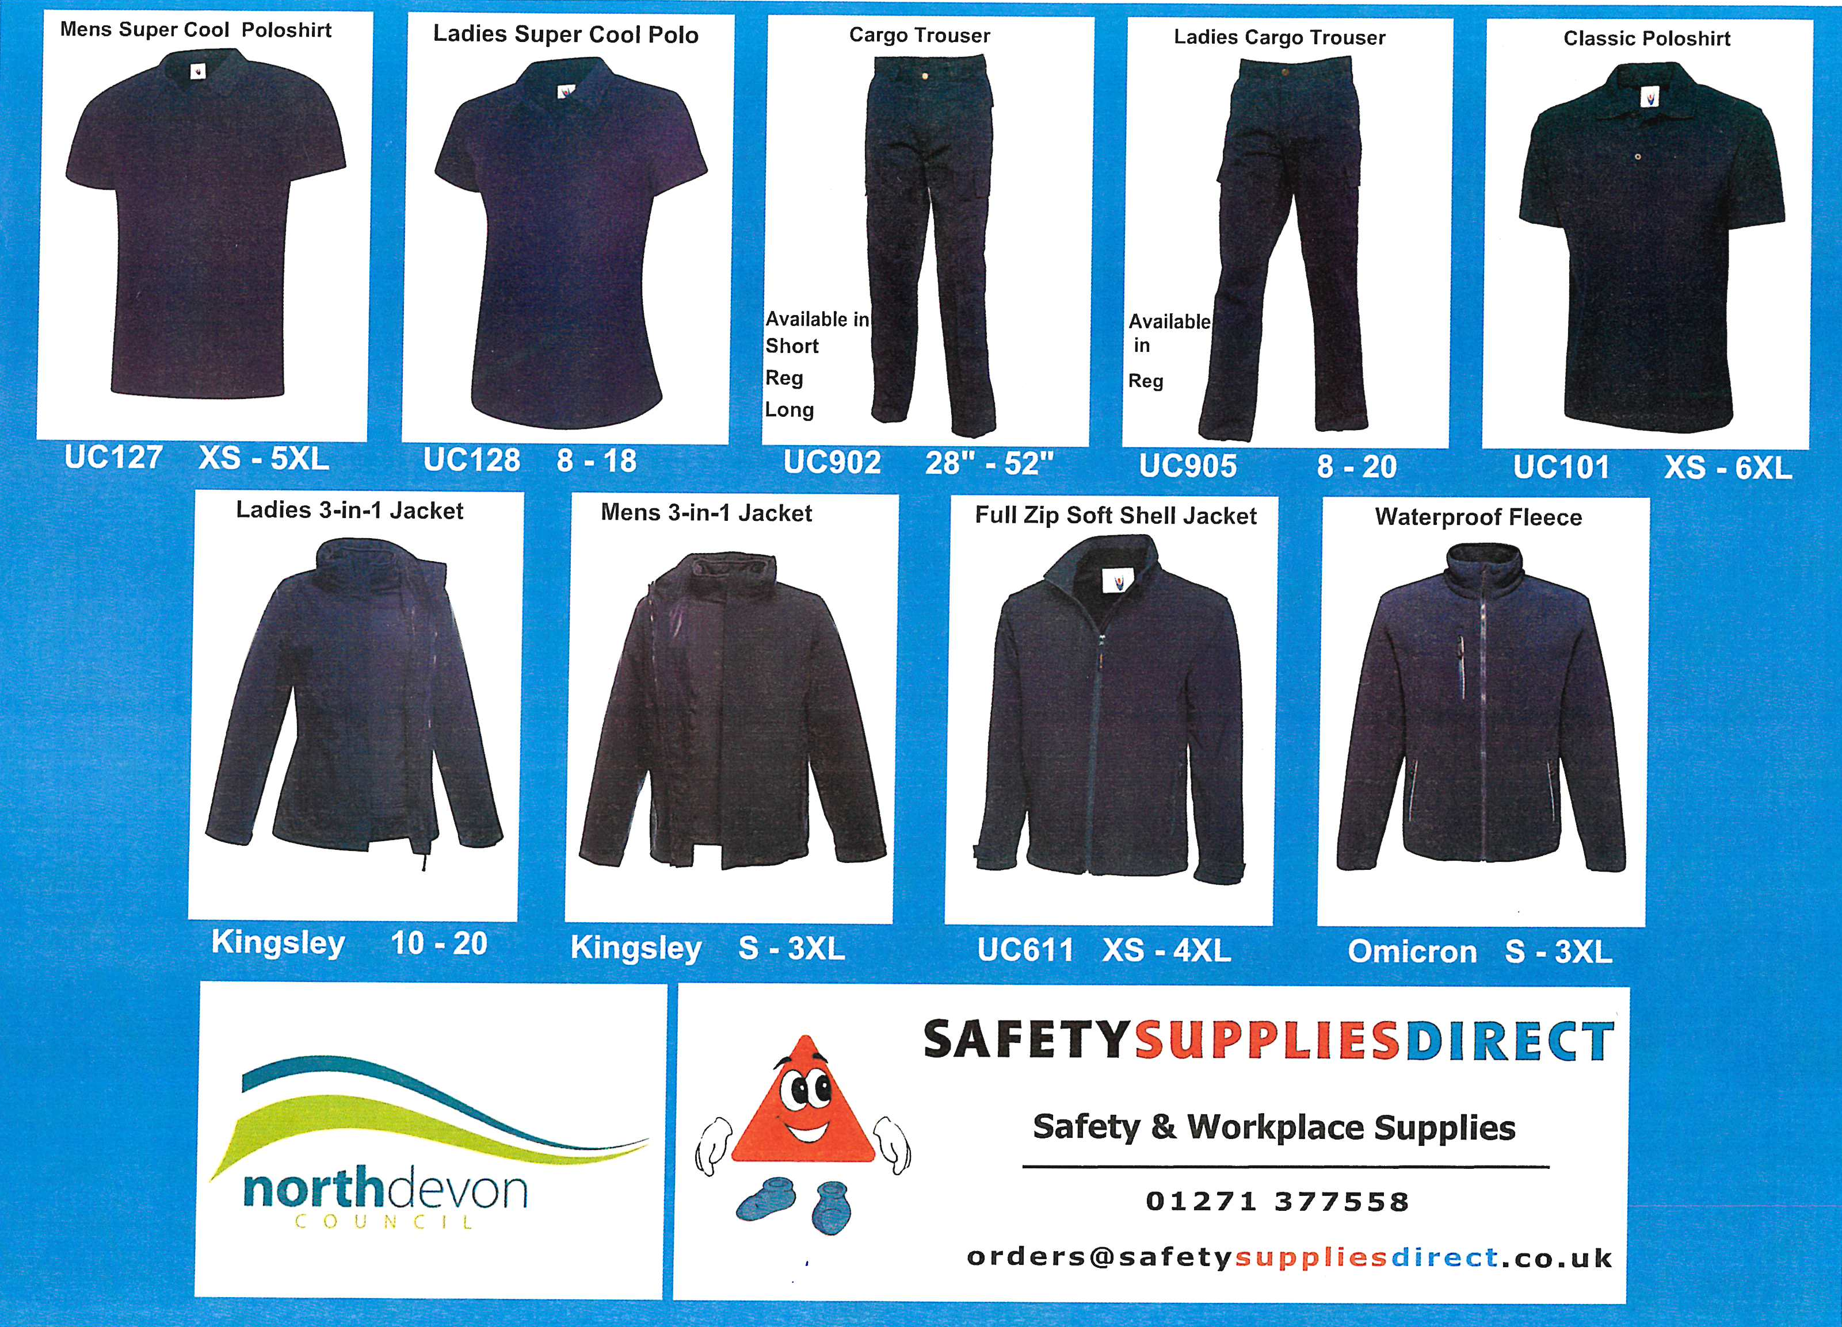
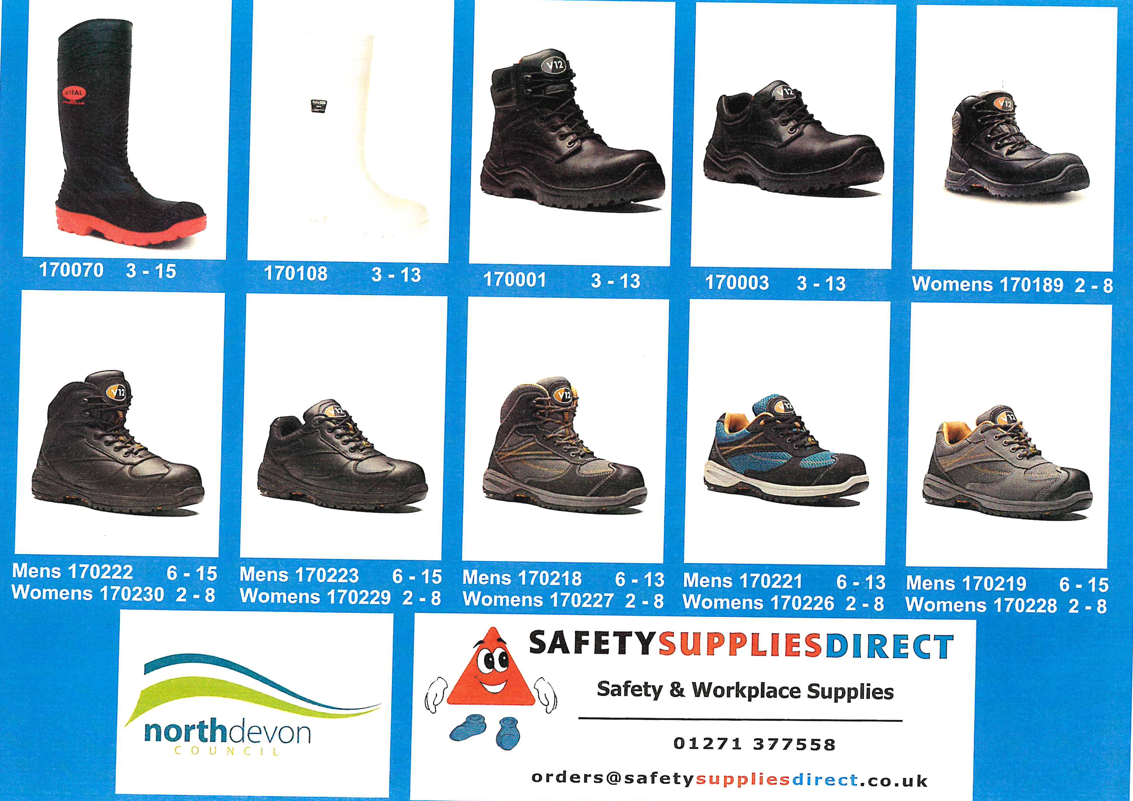
Full Time Staff:
1 x Boots/Shoes/Wellies
5 x T-shirt
2 x Trousers/ 1 x Shorts
1 x Jacket/Fleece
2 x Waterproof coat (not supplied by SSD)
2 x Jumper (not supplied by SSD)

Part Time Staff:
1 x Boots/Shoes/Wellies
3 x T-shirt
1 x Trousers/ 1 x Shorts
1 x Jacket/Fleece
2 x Waterproof coat (not supplied by SSD)
1 x Jumper (not supplied by SSD)

