THE RIGHT TO WORK IN THE UK

The law on preventing illegal working is set out in sections 15 to 25 of the Immigration, Asylum and Nationality Act 2006 (2006 Act), section 24B of the Immigration Act 1971 and Schedule 6 of the immigration Act 2016.
An employer must check that all prospective employees have the right to work in the United Kingdom or it risks breaking the law and could receive a substantial fine.

Please bring to your interview: original documentation ONLY

A passport showing that you are a British Citizen or a citizen of the UK and colonies having the right of abode in the UK; or Irish passport or passport card; or documents issued by the Crown Dependencies EU Settlement Schemes if you are a national of the European Union (EU), a European Economic Area (EEA) country or Switzerland. Sample documentation is shown below.

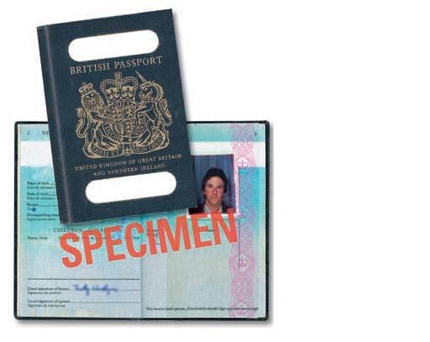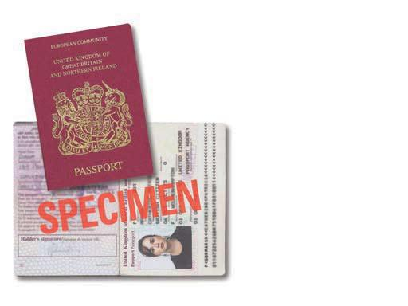

If you have a passport as described above this is the only document required for ‘the right to work in the UK’ and you do not have to provide those listed below.

IF YOU DO NOT HAVE A PASSPORT please bring to your interview:

A birth certificate (short or long version) issued in the United Kingdom which includes the name(s) of at least one of your parents.
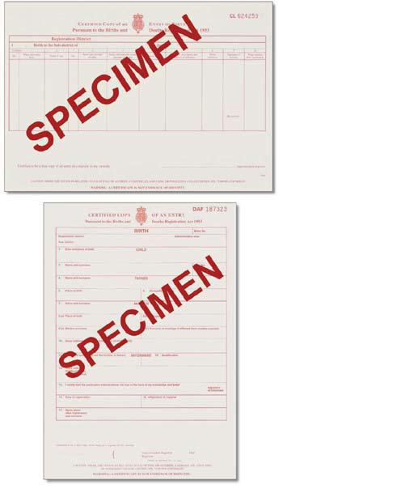
PLUS
one document as per below;
An official document issued by a previous employer or Government agency, e.g. HM Revenue and Customs, the Department for Work and Pensions, Jobcentre Plus, the Employment Service, which contains your name and National Insurance number.
e.g. a P45, P60, National Insurance number card, or a letter from a Government agency

If you are unable to produce a passport or birth certificate as specified above please call Human Resources on 01271 318550 prior to the interview.
Failure to provide the required documentation will delay or halt the recruitment process.

