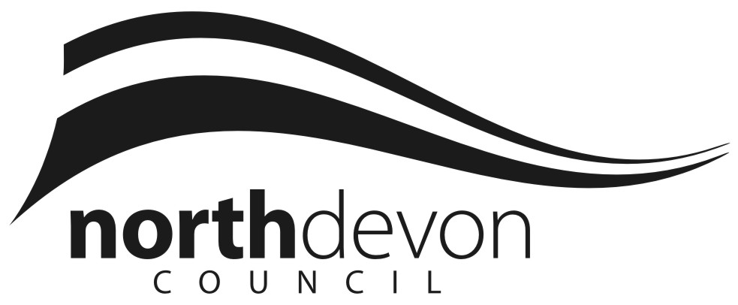

North Devon Council
Equality Strategy

2019 - 2023

Document Control

Organisation | North Devon Council
Title | Equality Strategy
Creator | Ken Miles
Source
Approvals | SMT
Distribution
Filename
Owner | Head of Corporate & Community Services
Review date | TBC

Document Amendment History

Version  No. | Originator of change | Date of change | Change Description
2.0 | Ken Miles | July 2018 | New Strategy
2.1 | Kate Johnston | April 2019 | Updates
 |  | July 2019 | Adopted at Strategy and Resources Committee

Equality Strategy
Version 2.1 / April 2019

Content

1. Introduction

2. The Equality Action 2010 and the Public Sector Equality Duty

3. Why is Equality important to the Council?

4. Equality in the delivery of our services

5. Equality in employment

6. Consultation and engagement

7. Our successes and achievements

8. Measuring our progress

9. How to contact us

Introduction

As an employer and deliverer of services, North Devon Council is committed to eliminate unlawful discrimination, promoting equal opportunities and fostering good relations between people from all communities. This Strategy sets out our commitment for progressing equality over the next four years.

The Strategy outlines our equality objectives, describes how we will fulfil our moral, social and legal obligations and what we will do to make North Devon a place where people get along with each other and treat each other with dignity and respect.

The Strategy covers inequality in terms of age, disability, gender reassignment (transgender/trans), marriage and civil partnership, pregnancy and maternity, race, religion or belief, sex and sexual orientation and is aimed at those who live, work in and visit the district, as well as elected Councillors and employees of the Council.

- The Equality Act 2010 and the Public Sector Equality Duty

The Equality Act 2010

The Equality Act 2010 came into force in October 2010 and legally protects people from discrimination in the workplace and in wider society. It replaced previous anti-discrimination laws with a single Act, making the law easier to understand and strengthening protection in some situations. The Act covers nine protected characteristics and these are the grounds upon which discrimination is unlawful. Every person has one or more of these protected characteristics, so the Act protects everyone against unfair treatment.

The characteristics are:

- age
- disability
- gender reassignment (1)
- marriage or civil partnership (in employment only)
- pregnancy and maternity
- race
- religion or belief
- sex
- sexual orientation

(1) Before, during and after transition. This wording is the terminology used in the Equality Act; transgender (or trans) is now the accepted terminology. The Council understands there are many different identities which fall under the trans umbrella, including identities outside of the gender binary.

As part of the Equality Act 2010, public authorities must comply with the public sector equality duty (the “equality duty”). The equality duty replaced the previous race, disability and gender equality duties and was developed to extend across all the protected characteristics. It consists of a general equality duty, supported by specific duties and requires public authorities to consider or think about how their policies or decisions affect people who are protected under the Equality Act.

Public Authorities must publish information to show their compliance with the equality duty as part of the decision making process. The information published must have due regard to the need to:

- Eliminate unlawful discrimination, harassment and victimisation and other conduct prohibited by the Act,
- Advance equality of opportunity between people who share a protected characteristic and those who do not,
- Foster good relations between people who share a protected characteristic and those who do not.

In addition, public authorities also have specific duties and must do the following:

- publish equality information at least once a year to show how they’ve complied with the equality duty,
- prepare and publish equality objectives at least every four years.

The publication of our Equality Strategy will support us in meeting the general and specific duties placed on us as part of the Equality Act.

- Why is equality important to the Council?

North Devon Council is reviewing the way services are delivered to the customer.

This is about looking at what we do from the outside-in or from the customers/residents point of view; it means understanding the different and sometimes multiple needs of our residents, including those who do not actively engage with the Council.

As a public service provider, it is important we recognise that our residents and customers come from different backgrounds. This will enable the Council to design and deliver services that meet the needs of the communities we serve. By understanding these differences and encouraging others to do the same, we can improve the quality of life for everyone by ensuring people who live, work or visit our district are treated fairly, with respect and are given the same chances and opportunities by taking into consideration their different needs.

As an employer, we believe that it is in the Council’s interests and in the interests of all who work for the Council, that we ensure that every possible step should be taken to ensure that individuals are treated equally and fairly and that decisions in recruitment and selection, training, promotion and career management are based solely on objective and employment- related criteria and that reasonable adjustments are made where feasible.

- Equality in the delivery of our services

Equality Impacts

There is no longer a specific legal requirement for the Council to undertake an equality impact assessment. However, we are legally required to demonstrate that we have given ‘due regard’ to eliminate unlawful discrimination, harassment and victimisation; advance equality of opportunity and foster good relations. In practice this means that equality considerations still need to be evidenced in our decision-making processes and policies. Any potential impact on equality should be considered before any key decisions are made and should be integrated into day-to-day policy-making, business planning and other decision-making arrangements. This is particularly relevant when making difficult financial decisions; if we are proposing to stop, reduce or change a service then we must have relevant equalities evidence to justify this.

Our Dignity at Work Policy and Equality Assessment Guidance is available for officers on the internal website. Further guidance and assistance is available from the Human Resources Manager.

Equality Monitoring

The Council has a requirement to publish equality information at least once a year to show how we have complied with the equality duty. The Council recognises this also makes good business sense as it can help local people assess the Council’s performance on equality, the impact our policies and practices have had, tell us who is and isn’t using our services; understand why our services may not meet their needs and help us to improve the delivery of our services by identify any data gaps and address any issues. Any monitoring undertaken must be proportionate and relevant and of a benefit to our communities.

Procurement & Commissioning

The Council provides a wide range of services to residents and businesses in the area. In some cases these are provided directly by the Council, in other by our partners and contractors. When a supplier provides goods, services or works on our behalf, we will ensure the equality obligations are part of the terms of a contract so that we know they will monitor the impact on service users and those they employ. The ultimate legal responsibility for meeting the requirements of the Equality Act remain with the Council for any services delivered on our behalf.

Specifically we will;

- Communicate this strategy to all potential contractors and service providers,
- Ensure contractors and service providers have policies, procedures and practices that do not discriminate and deliver goods, facilities and services that are appropriate and accessible,
- Provide opportunities for all to be in a position to bid and win council contracts on an equal basis and
- Monitor the contracts and service arrangements to ensure they are meeting their equality commitments.

- Equality in employment

The Council is working towards achieving a diverse workforce and offering equality of opportunity in employment, recruitment selection, training and development. We aim to ensure that the workplace is free from discrimination, victimisation or harassment of any kind where staff are treated with respect.

Employment policies

The Council has a wide range of policies in place for our staff and prospective employees. These policies support our staff and provide clear guidance to all employees about what is expected of them and what they can expect from us as an employer. We will continue to review the range of policies and be pro-active in promoting and supporting equality in the workforce. This includes eliminating bullying and harassment, addressing discrimination, ensuring equality in pay and creating a flexible work-life balance.

The Equal Opportunities Policy pulls together the Council’s commitment to equality within the workplace.

Equality Training

Equality training is provided for staff to ensure they are made aware of their rights and responsibilities. In particular all managers will be trained on a regular basis in equalities matters concerning employment. Similarly there is an expectation that all Councillors will attend Equality training.

Equality issues are an integral part of our training and development programmes, regardless of whether the council uses internal or external trainers.

In addition to the generic equality training, tailored equality training to reflect the needs of specific services will be encouraged, particularly for services engaging with external customers and / or where there is a significant engagement with protected group(s).

The Council makes a strong commitment to training and development for all staff. All staff will have equal access to training and development and we will take positive action where appropriate for those who are underrepresented in our workforce.

- Consultation and engagement

The Council wants to ensure that anyone who accesses council services either as a resident, visitor, customer or employee feels well informed about local issues; has the opportunity to get involved, influence local decision making and gets the opportunity to tell the Council what they think about its policies, procedures, service delivery and work with partner organisations.

The Councils aim is to help everyone in North Devon have the opportunity to feel informed, consulted and involved in how their council makes decisions and delivers services.

To achieve this, the Council will:

- Develop a strategic approach that provides clear guidance and promotes successful engagement across all service areas
- Plan and co-ordinate activities, the use of resources and, where possible, work collaboratively
- Actively encourage involvement from all communities, including those from traditionally ‘hard-to-reach’ groups so that everyone has a chance to represent their viewpoints on issues relevant to them
- Use the most appropriate method to consult and engage making the experience interesting, relevant and worthwhile for participants
- Develop and implement new approaches to how we carry out engagement activities.
- Communicate results and ensure that the outcomes are used to inform the Council’s policies and decision-making processes
- Use the information from our engagement activities, alongside other evidence, to inform the design and delivery of effective and efficient services, within our current financial constraints.

As a Community Leader and a public service provider, North Devon Council considers, as a matter of course, the needs, desires and aspirations of its people and the communities they form. This means:

- Providing information on the things we are doing or planning
- Consulting with communities and involving them in what the council does
- Ensuring that all communities are able to influence the decisions and direction of the council.

If you would like to get involved taking part is easy and you can do as little or as much as you like e.g. from completing surveys on local issues to being part of a focus group. Your views can make a difference.

All of our current consultations can be found on our website at www.northdevon.gov.uk/consultations

- Our successes and achievements

- Disabled Facility Grants – Available to assist with costs of improving access to, and facilities within properties, eg installation of wet-rooms, stair-lifts and ramps.
- Community Councillor Grants – Awards made to groups and organisations to finance projects which benefit the local community.
- Communities Together Fund awards – Awards made to groups and organisations to finance projects which benefit the local community.
- Promoting Lesbian Gay Bi-sexual and Transgender (LGBT) events with the Sunrise Organisation through the award of Community Councillor grants and promotion of events via the regular “Grants and Community News” newsletter.
- Community Safety Partnership – Working in partnership with a neighbouring Local Authority, Devon and Cornwall Police, Devon and Somerset Fire and Rescue Service, and Dorset, Devon and Cornwall Community Rehabilitation Company to consider wider issues, such as crime prevention and anti-social behaviour, and how together we can respond to local issues and improve quality of life for residents.
- Provision of equality training for Officers and Councillors.
- Council Tax Reduction Scheme – Financial assistance for those in need of help towards the cost of Council Tax. This could be for students, those living alone, or those with a severe mental impairment.
- Assistance with applications to the ‘Devon Home Choice’ housing register.
- Redesign of council car parks to ensure they have good disabled access, along with accessible signage and payment machines.
- Installation of hearing loop as part of the refurbishment of the Museum.
- Improved access and installation of hearing loop at the Crematorium.
- The installation of an element of inclusive play equipment when replacing equipment. Improvement of disabled access to public buildings where possible.
- Consideration of disabled facilities as part of development process for new projects.
- Make information accessible by considering the needs of potential and existing customers. We take steps to make all information as accessible and easy to read as possible, with the use of plain English and provision of alternative methods of communication when required. This includes large print letters, telephone calls, visits, translation and interpretation services and a range of contact methods on offer.
- When publishing content on the Council’s website follow web-accessibility standards.
- Ensure accessibility of Council meetings and events by using venues that are accessible when possible.
- Provision of hearing loop systems at face to face Council customer service sites at Lynton House, the Ilfracombe Centre and the Amory Centre at South Molton.

- Measuring our progress

We will inform the public and staff about our progress through:

- An annual equality report
- Our information and advice services
- Council website
- Media (including social media) for advertising and press releases
- Our community networks
- Annual report on Gender Pay Gap for NDC employees

- How to contact us

To give us your views, get involved or for further information please contact equality@northdevon.gov.uk or 01271 388253

To find out about the councils engagement activities please contact us or visit www.northdevon.gov.uk/consultations

If you need this information in another language or format, please contact us to discuss how we can best meet your needs.

