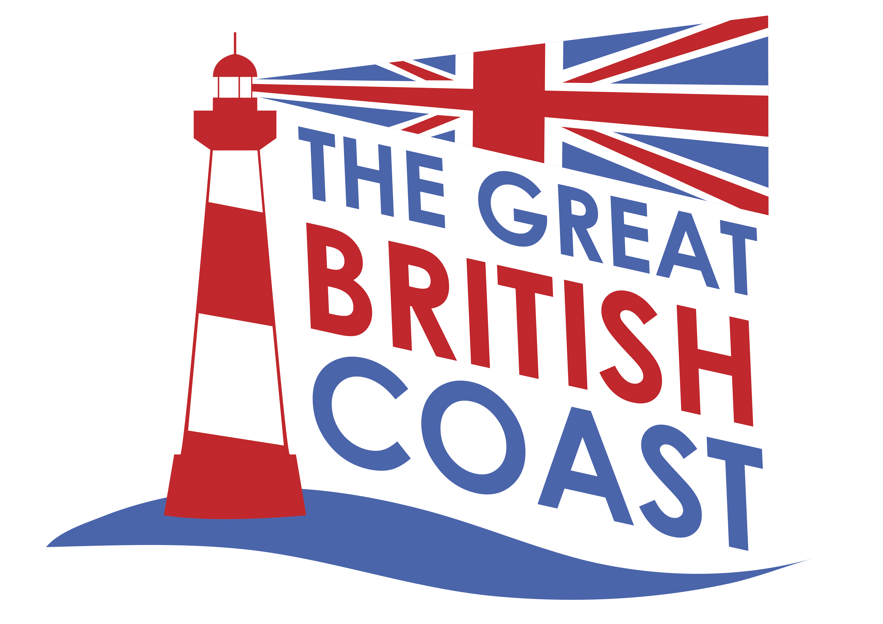

Ilfracombe Coastal Community Team

***Economic Plan***

January 2016

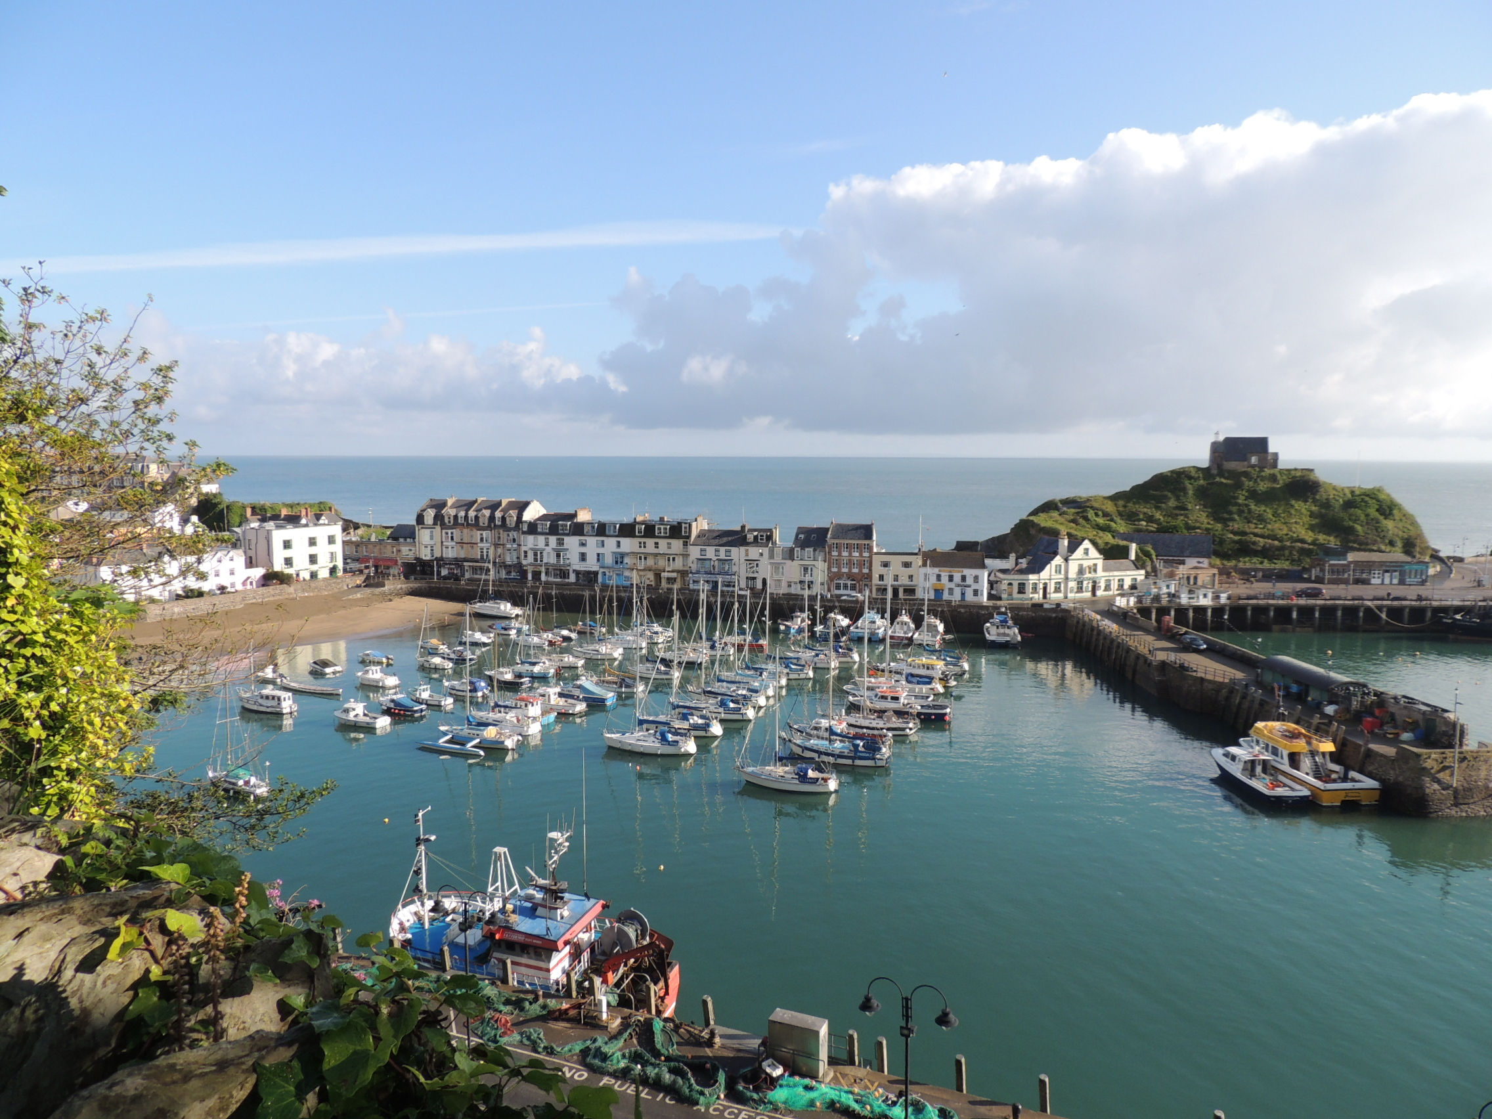

1. **Purpose**

The purpose of this document is to outline our plans for economic growth through development of the visitor economy and spreading the opportunities and benefits around the community in Ilfracombe. This plan is set in the context of Ilfracombe’s plans for regeneration through growth. The Plan has been prepared by the One Ilfracombe Coastal Community Team (CCT) based upon recent local consultation and many previous studies which enabled prioritisation, both of the range of issues to be addressed and the key projects to tackle them.

Ilfracombe has a long history of attracting visitors to the town, attracted especially by the harbour area. However, while the tourism industry forms a substantial part of the local economy, we need to do more to ensure that it delivers benefits for all in the community and that the whole town works better together to that end.

1. **Context**

This section incorporates analysis from the various reports and studies listed in Section 3.2.

* 1. ***The local area***

The parish area of Ilfracombe (see Fig. 2.1) stretches along the coast 4 miles from Hele Bay in the east to Lee Bay in the west and several miles inland where the terrain rises to 860 feet/270m. The hilly topography is due to the underlying geology of Ilfracombe slates, a sedimentary rock severely folded and faulted 300m years ago. Hillsborough Hill, the site of an Iron Age settlement, overlooks the natural, safe harbour which led to Ilfracombe becoming a significant port on the Bristol Channel. Other ancient features indicating the deep roots of the town include St. Nicholas’s Chapel and lighthouse on Lantern Hill where a light or beacon has guided ships since 1361 and the 13th century Holy Trinity Parish Church. Having been two distinct farming and fishing communities, tourism changed the face of the town from early Victorian times when, in the 1820’s, a set of four tunnels were hand carved by Welsh miners to provide access by horse drawn carriage as well as by foot to the beaches and two tidal pools.

The population grew to over 9,000 in the early 20th. century and then there was a further influx during the tourism boom times of the 1950’s when over 10,000 holidaymakers would arrive by railway, and others by passenger ferries, each Saturday at the peak. At that point, the local workforce was insufficient to provide the services needed and inward migration from Northern cities alleviated that problem but also led to social friction. Then in the 1960’s, foreign holidays became affordable for a much higher proportion of the population and the closure of the railway in 1970 triggered a significant decline in numbers reaching Ilfracombe, with consequent higher unemployment.

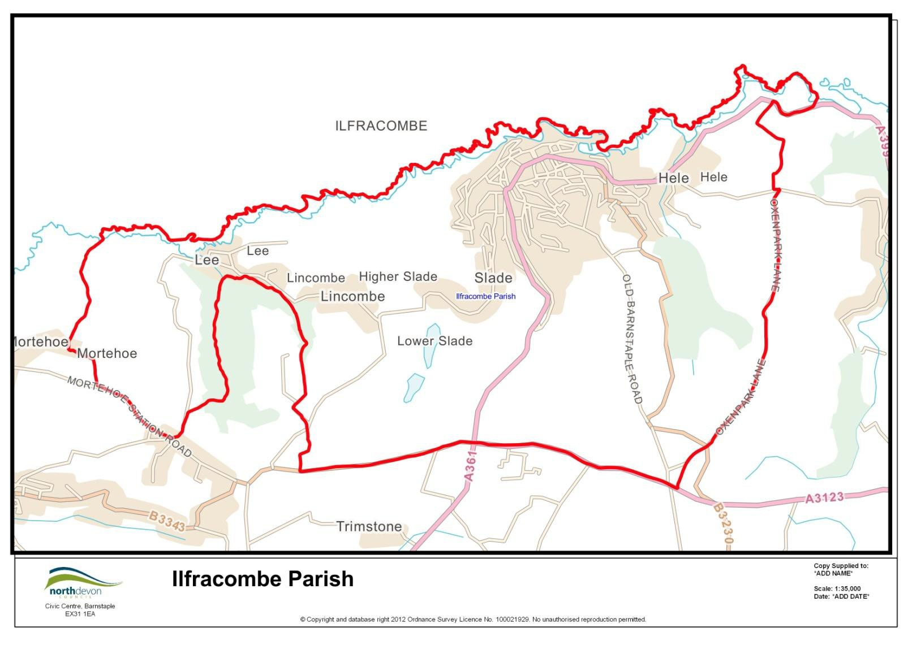

***Figure 2.1***

During the following 25 years, the balance of activities changed markedly with the introduction of two large, light manufacturing employment sources, in Pall Europe and TDK-Lambda. Also there was a series of nine major fires which destroyed many of the early Victorian hotels and some other features in the town. A highly prominent new feature was the Landmark theatre with its unusual, double-conical design. Then more recently, Damien Hirst’s sculpture ‘ Verity’ has provided a new focal point by the harbour, acting as a symbol of the growing artistic community.

Reflecting the economic difficulties faced by the area, Ilfracombe’s population was static during 1991-2001, grew less than 3% in the following ten years and continues to increase at a much slower rate than most other towns in the southwest. Nevertheless, the resourceful community has been tireless in seeking to reinvent and represent Ilfracombe through a series of regeneration programmes. The vision for the town now embraced by the town’s Strategic Plan and the North Devon and Torridge Local Plan is of ‘regeneration through growth’. It is envisaged that growth will support construction jobs and have knock on economic benefits, as well as providing a larger local population to support shops and services within the town centre. The greater critical mass will arise from 1,420 new homes provided for in the Local Plan to 2031, including a major urban extension and additional employment land. New building on a number of vacant sites in the town particularly will help to enhance the town’s historic character and tourism potential.

Ilfracombe’s history and heritage is rightly valued as a significant attraction for visitors. The town’s Conservation Area (79 ha) is the largest in North Devon by some margin and includes 124 listed buildings, reflecting not just the town’s medieval settlements, but also its development as popular tourism destination, including Georgian terraces constructed to provide high quality accommodation in the manner of spa towns such as Bath, Buxton and Cheltenham; and former grand Victorian Hotels. Focal points for culture and heritage are the Landmark Theatre and Ilfracombe Museum, which is located within the former laundry of the Ilfracombe Hotel.

Ilfracombe is blessed with a high quality environment, heritage and landscape setting, recognised through the designation of North Devon Area of Outstanding Natural Beauty and Heritage Coast plus several Local Nature Reserves covering 40 hectares, as well as the extensive Conservation Area. These environmental assets create the setting for the harbour which is the town’s single biggest resource capable of attracting development of sufficient scale to facilitate a step change in the town’s economy (Ilfracombe Town Study). While acknowledging that fact, this Plan is designed to ensure that all parts of the town, including the seafront and High Street, pull together both to contribute to and share in the benefits of a revitalised visitor economy.

* 1. ***Community context***

Ilfracombe’s population in 2011 was 11,509 with 17,758 in the wider ‘town area’ (including the parishes of Berrynarbor, Bittadon, Combe Martin, Kentisbury, Morthoe and West Down). At that time, 23 % of residents were aged 0-19 and 28.1% aged over 60; compared with the rest of North Devon and Devon County, this is a slightly younger population. Life expectancy at birth is nearly four years less than the Devon average, with generally poorer health prevalent at all ages. According to Mosaic data, the population types which dominate are people within small-medium towns with strong local roots (29.3% cf. Devon 17.8%), isolated rural communities (23.3% cf. 19.5%) and active elderly in pleasant retirement locations (16% cf. 12.4%).

Above average deprivation is a significant feature, especially regarding incomes, employment levels, living environments, crime, health and disability and skills and training. 27% of the population falls within the 25% most deprived in England. The high density development of housing terraces, many built during the Victorian era, is associated with relatively poor standard accommodation and correspondingly low prices. Many larger properties have been subdivided into flats (comprising in total 30% of the housing stock) and approaching 25% of housing is in the private rented sector. Other notable aspects of life where Ilfracombe has significant variances from Devon averages are:

* Birth rate: 71.2 births per 1,000 females, (statistically higher than the Devon rate c.58)
* Life expectancy: 77.3 years, (statistically lower than Devon rate 81.0)
* BME population: 1.8%, (Devon rate 2.5%)
* Youth offending: 15.7 per 1,000 children aged 10-17 (statistically higher)
* 5 GCSEs A-C: 37.3% of DCC pupils, (statistically higher Devon rate 58%)
* Aged 65+ in care homes: 30.1 per 1,000 aged 65+ (statistically higher)
* Domestic violence: 15.4 per 1,000 population aged 18+ (statistically lower)
* Hospital admissions: 4,282 all elective per 100,000 population (statistically lower)

While there is a good range of community facilities, health services in particular appear near to capacity and the housing growth now anticipated would require many additions or enlargements.

* 1. ***The local economy***

The most prominent sectors of the northern Devon economy are retail, health and social work, accommodation and food, manufacturing, education and construction which together account for 75% of employment (drawing on data from the 2011 census). In Ilfracombe in 2013, the largest employment sectors were manufacturing 20.7%, health and social work 16.8%, wholesale and retail 15.6% and accommodation and food 15.2%. The Vision for the North Devon and Torridge economy in the Local Development Framework Plan draft is for *“a diverse and resilient economy that can adapt to* challenges *and maximise opportunities, underpinned by an appropriately skilled workforce and effective infrastructure”*. Visitor numbers and spend are regarded as one of the key economic drivers. Furthermore, town centres will be protected and enhanced by focusing developments for retail, leisure, office and cultural facilities within defined centres, with positive management of regeneration measures. Also, high quality tourism development will be promoted to encourage a year round industry which is sustainable and avoids damaging natural and historic assets. The emphasis will be on quality and priority given to existing facilities and destinations.

In Ilfracombe, relatively low wages and low skills are the fundamental issues requiring a range of long term solutions. There is a high number of micro and small businesses and a relatively low level of enterprise formation in North Devon, about two thirds of the GB average. While the number of business units in Ilfracombe did grow by 2% during 2011-14, the rate of growth nationally was 7%.

The Demand and Economic Impact Assessment for an Ilfracombe-Swansea Ferry conducted in 2015 suggested that Ilfracombe’s estimated tourism market in 2013 was 219,157 staying and 715,680 day visitors spending a total of £79,199,857 which supported 2,179 jobs (1,554 FTE).

A retail study for the town (CACI, 2010) calculated that Ilfracombe’s core catchment (from which most of the town’s trade is expected to originate) was 14,473 people and total catchment was 36,301, with a potential comparison goods spend (for goods were shoppers are more likely to visit larger centres) of £26.4m, representing a market share of 28.6%. For leisure activities, the core and total catchment populations are 15,561 and 85,126 with potential spend of £16.2m and a market share of almost 20%.

A recent business survey in the town highlighted staff recruitment challenges with over a quarter of firms having some difficulties. On the other hand, many of these businesses had invested last year and proposed to do so in 2016, either in capital, infrastructure, marketing, increasing their product range or training. The positives about trading in Ilfracombe included it being an up and coming place, with lots of potential, a friendly place with great community spirit and a great place to live and work. The negatives were cited as being seasonal, a difficult environment, poor area with some anti-social behaviour. Proposed improvements which would most benefit business were felt to be better parking arrangements, cleaner streets, more advertising and promotion attracting more customers and better bus and Dotto land train routes.

* 1. ***Related initiatives***

The scale of ***housing development*** envisaged (1,420 new homes over the next 15 years plus more refurbishment of rented housing) should not be underestimated in terms of the increased demand for local services and the economic benefits which will flow from such provision. Also, release of additional ***employment land*** at Mullacott Business Park, and as part of the Southern Extension should entice more manufacturing and other industrial activity, in turn raising demand for higher skills and boosting income levels.

Of more direct relevance to the themes of this Plan are the ***regeneration initiatives*** in and close to the town, especially those schemes around the harbour and seafront which will provide opportunities for tourism, marine, leisure and recreational facilities while improving traffic management. As well as improved infrastructure around the harbour for both commercial and recreational boat users, potential new services, such as the ***proposed new ferry to Swansea***, would open up new markets.

The Verity statue on the harbourside is indicative of the ***growing artistic community*** associated with Damien Hirst and others and of the scope for more public art installations around the seafront and town.

***North Devon Tidal Demonstration Zone*** - waters off the coast at Ilfracombe have this designation which would allow testing of new marine technologies ‘to accelerate the rate of wave and tidal current technology, to both increase the readiness of technologies and work towards cost reduction’. Every Zone has appropriate wave or tidal resources and satisfies other criteria necessary for test and demonstration projects to be successful. This site has the potential to support the demonstration of tidal stream arrays with a generating capacity of up to 30 MW for each project and offers scope for collaboration with Plymouth, Exeter and Bristol Universities, support from the Heart of the South West Local Enterprise Partnership, with marine renewable energy as a priority for use of EU Structural Funds, and access to support from the South West Marine Energy Park.

This Tidal Demonstration Zone presents a number of commercial opportunities for Ilfracombe, including port services for offshore installations, workboats for survey contracts, operations and management support, and accommodation and hospitality services. As one of the original sites in this country for wind generation, Ilfracombe is ideally placed to make renewable energy a key theme both in its economic development portfolio as well as in applications to improve domestic energy efficiency and reductions in fuel poverty.

Ilfracombe is a ***significant service centre*** for a number of villages along the coast, such as Combe Martin, Berrynarbor, Lynton and Woolacombe. The additional visitor attractions in these communities, as well as the North Devon Area of Outstanding Beauty which ties them all together, make for a very varied tourist destination with great environmental and cultural interest.

***Transportation*** – Devon County Council is working on a strategy to improve the A361/A39 North Devon Link corridor designed to increase capacity, reduce journey times and make access to North Devon easier and more attractive. Additionally, Network Rail and Great Western plan to reduce journey times to under 60 minutes on the railway between Barnstaple and Exeter. Great Western Railway also plans to expand car park capacity at Tiverton Parkway station.

1. **Methods**
   1. ***About the Coastal Community Team***

This Plan has been developed by the One Ilfracombe Coastal Community Team, which sits within the established town partnership organisation – One Ilfracombe. One Ilfracombe comprises a Town Team (made up of police, fire, museum, tourist information, street cleaning, harbour and parking staff); an Ilfracombe Works team (made up of large employers, tourism businesses, Jobcentre and schools); and a Living Well team (made up of local and regional councils, North Devon Healthcare Trust, Devon Partnership Trust, NEW Devon CCG, North Devon Homes and other local healthcare professionals). Ilfracombe Town Council also has a Tourism Marketing Group. The Coastal Community Team is a separate team made up of representatives of each of these groups to ensure co-ordination and avoid duplication.

Members of the team include representation from:

Ilfracombe Town Council

Devon and Cornwall Police

North Devon Council

Ilfracombe Tourism Information Centre

Ilfracombe & District Tourism Association

Ilfracombe Tourism Marketing Group

Events 4 Ilfracombe

COMBE Business

Ilfracombe Museum

Ilfracombe private businesses

* 1. ***How our Plan was developed***

The focus of this Plan has been shaped by numerous studies and project proposals, backed up by a wide variety of public consultation, during the past five years. Dialogue and survey of the business community was particularly helpful in framing the proposals. The main reports providing background details include:

* Publication Draft North Devon and Torridge Local Plan, 2014
* Northern Devon Economic Strategy 2014-20
* Ilfracombe Town Strategy: One Ilfracombe/Ilfracombe Town Council Strategic Plan 2010-2020
* Joint Delivery Team Business Plan 2011
* Ilfracombe Town Study, Core Strategy Evidence, 2011, North Devon Council
* Joint Strategic Needs Assessment Town Profile for Ilfracombe 2013-14, Public Health Devon/Devon County Council
* Ilfracombe: Economic Research 2010, CACI for North Devon+
* Census Profile: Ilfracombe Town Area, figures at 2011, DCC
* Ilfracombe area baseline profile, using Mosaic data from 2009, DCC
* Ilfracombe area Town Profile, data from 2010/11, DCC
* Ilfracombe-Swansea Ferry: Demand and Economic Impact Assessment, 2015

Distillation of these reports and the supporting evidence has informed the CCT and the priorities and initiatives proposed. Consultation has included a survey of local businesses in 2015 and presentation of the results to a representative sample in November, with their recommendations being incorporated into the Plan. The Team has then elaborated and refined the projects presented in this document.

Ilfracombe has an extraordinarily strong record of partnership working in recent years, culminating in the creation of One Ilfracombe. One Ilfracombe grew from the national Our Place! Pilot (see <https://oneilfracombe.org.uk/>) and sets out to redesign the way services are delivered locally to achieve better outcomes for the people who use and pay for them. This offers local people more say over services and expenditure. By bringing services, businesses, schools and residents together into one team, we can achieve so much more and be in a better position to fulfil our aims of ‘Better health, economic prosperity and a high quality living environment for the people of Ilfracombe’. This has provided the perfect springboard to establish the Coastal Community Team and prepare this Plan which is based on very firm foundations.

The five aims of the Team specified at the outset were to:

* Balance the regeneration of Ilfracombe across the area,
* Increase footfall to and through the town centre,
* Support the retail sector throughout the town,
* Overcome seasonal fluctuations through the creation of a year-round offering,
* Promote and safeguard the area’s heritage assets.

During the Plan preparation, potential projects became grouped under six working headings:

* Shopping locally,
* Communications with all businesses,
* Harbour area,
* Cohesive positive attitude,
* Parking and loading,
* Better town advertising.

Using the basic structure of a Logical Framework Matrix[1], these project groupings have been reworked into functional themes and to show a clear link between every action and the ultimate purpose of developing the visitor economy and spreading the benefits of tourism around the whole community. This matrix also helps to plot the linkages between the various projects and provides a good basis for monitoring outcomes and outputs.

1. **Our Plan – aims & objectives**

**The aim of our Economic Plan** is to develop the visitor economy within Ilfracombe in a joined-up way that spreads the benefits of tourism around the community and so making the town work better together.

Our key **objectives** are:

* To make the High Street more attractive to shoppers,
* To improve facilities for users of the harbour,
* To increase pedestrian flows between the harbour, seafront and High Street.

The means of achieving these objectives will be through:

* Product and service development, adding to the quality of shopping and visitor services;
* More effective use of communication channels, co-ordinating use of different media for targeted promotions;
* More effective use of support systems, providing a cohesive approach to business support and development.

1. **Community needs and supporting data**

Data summarised below is drawn from a number of sources listed in section 3.2.

***Demography*** – population growing slowly:

* Ilfracombe’s population of 11,509 is growing more slowly than elsewhere and is slightly younger than in the District and County,
* The birth rate is much higher than the County average,
* Life expectancy is notably less than the Devon average,
* 32% are one person households cf. to 30% in Devon with an 18% rise in single people and 10% drop in those married during 2001-11.

***Income*** – income levels are well below average:

* Incomes in North Devon are 7.5% less than the Devon average. Average income levels vary substantially between Ilfracombe’s three wards - Central Ward having an average of £20,587 in 2008, East Ward £24,280, West ward £24,218 and Devon £26,112..
* Proportions of residents receiving benefits are substantially higher than the Devon averages:
  + Income Support 7.7% cf. 4.5%;
  + Job Seekers Allowance 2.8% cf. 2.0%;
  + Disability Living Allowance 6.1% cf. 4.2%;
  + 65+ Attendance Allowance 19.1% cf. 17.3%;
  + 60+ Pension Credit 25.6% cf. 15.3%.
* Deprivation - 27% of the population falls within the 25% most deprived in England and Wales with some neighbourhoods in the most 10% deprived; the main barriers are income, employment, skills and training, and the living environment, crime, health and disability concentrated in small localities in each ward. 12.7% of children are in poverty and 7% of households in fuel poverty.

***Education & skills*** – skills levels are well below average:

* 62 % of school pupils obtain 5 or more GCSEs A-C compared with 74% in Devon and 80% nationally, with just 38% having A-C including Maths and English (cf. Devon 58%);
* 41% of the working age population has less than a Level 2 qualification (cf. Devon 34%) and 21% have Level 4 or higher (cf. 28%).

***Economic activity*** – overall, low levels of economic activity:

* 29% of residents aged 16-74 are employed full time, compared with 34% in the county.
* 16% employed part-time, 29% full-time, 16% self-employed, 4% unemployed, 5% students, 19% retired, 9% looking after family/long term sick/disabled with large seasonal fluctuations.
* 35% males employed full time cf. to Devon 42%.

***Employment*** – there are higher proportions of people in manufacturing and accommodation and food service than the Devon averages:

* Manufacturing 22.6% cf. Devon 8.4%; wholesale/retail 18% cf. 18.6%, hotels/restaurants 15.4% cf. 10.1%; business activities 11% cf. 16%.
* 25% of the workforce is a manager or in a professional occupation compared to 24% in Devon and 17% are in skilled trades compared to 16%.
* The vast majority of businesses are micros and small enterprises with only two large employers within the town. There is a relatively low level of enterprise formation.

***Tourism activity*** – tourism is a significant and important part of the Ilfracombe area’s economy for the income generated and the sense of place and civic pride which are reinforced. There is potential for Ilfracombe to increase spend per visitor:

* Tourist visitor numbers were estimated as being 219,157 staying and 715,680 day visitors in 2013, spending a total of £79,199,857 and supporting 2,179 jobs (1,554 FTE) (Ferry Economic Impact Assessment);
* The Ilfracombe area has 2,950 serviced bed spaces, 490 flats/houses, 2,250 holiday park bed spaces, 1,500 touring pitches (Ilfracombe Town Study);
* Tourism income is earned by retail £12.2m, catering £17.1m, entertainments/attractions £6.4m, accommodation £15.1m and travel £9.3m;
* Staying holiday makers contribute £39.4m, day visitors £19.2m and those visiting friends and family £1.5m (2008 figures from the Ilfracombe Economic Research report by CACI, 2010);
* Ilfracombe’s share of the North Devon and Torridge tourism market of £363.3m is 16.6% (CACI study);
* Particular visitor ‘likes’ are the scenery (beaches, coastal paths, harbour) and general ambience, and described the town as peaceful, friendly, quaint, relaxed, less commercialised, not too modern;
* The harbour is the most popular attraction, mentioned by 84% of visitors surveyed, and most highly rated with 93% regarding it as good or excellent, giving an ‘upmarket coastal town feel’;
* Dislikes are rundown, tired and tatty appearance of some areas, especially the High Street which was visited by 76% and rated as poor or very poor by 25%; other dislikes are narrow pavements, lack of footpaths, poor access for the elderly, lack of car parking and the charges, traffic congestion and poor signage;
* There are poor connections between harbour, seafront, High Street.

***Retail market*** – Ilfracombe’s market share for comparison goods is 67%, and 91% for food and drink of its **core** catchment due to its remoteness:

* Ilfracombe’s **total** catchment population for comparison goods shopping numbers 36,301 with spend of £92.4m; it’s market share is 28.6% with 19.7% leaking to Barnstaple (figures drawn from the Ilfracombe Economic Research report conducted by CACI, 2010);
* The food & drink catchment is 85,126 people with spend of £81.2m; Ilfracombe takes 19.9% market share, 53% leaking to Barnstaple;
* The catchment population is polarised between ‘affluent greys’ 30% and ‘Blue Collar Roots’ 20% (with the UK averages being 8% for each) and 15% ‘aspiring singles’; these three groups have very different shopping needs;
* Compared with benchmark towns, more comparison goods shops would be expected (currently 34% compared with benchmark of 50%) and better quality (22% are gift shops and 15% charity shops);
* There is particular scope for more clothing, footwear and leisure goods shops and more upmarket restaurants;
* Only 13% of shops are multiples, so there is scope for several more;
* There is an over representation of newsagents (21% of convenience units);
* 64% of those surveyed within the CACI study suggested improvements to the retail mix.

***Community issues*** - Ilfracombe has a good number and range of community facilities, health services and public transport but with considerable potential to upgrade; housing standards are relatively poor:

* While community facilities and services are broadly satisfactory currently, many are near capacity, especially GP surgeries, and there is demand for new youth facilities;
* Over 60% of those employed, work in the town, with 22% walking to work, and approaching 20% work in Barnstaple;
* 22% residents are limited to some extent in their day to day activities by health issues (20% in Devon);
* There is a need to improve skills and training opportunities for young people;
* 7% homes have no central heating (5% in Devon); 65% are owner occupied (70% Devon) and 25% privately rented (16%);
* 45% houses are detached or semi-detached (Devon 60%) and 30% are flats (15%);
* Prices for all types of housing are around two thirds of Devon averages;
* 23% households have no car (Devon 17%);
* House prices have fallen to near the national average which is little more than two thirds the Devon average, reflecting the predominance of 19th century terraced housing.

1. **SWOT analysis of the town’s ability to take advantage of the visitor economy**

|  |  |
| --- | --- |
| **Strengths** | **Weaknesses** |
| * Harbour * Heritage and listed buildings * Seafront and beaches * Coast and Area of Outstanding Natural Beauty * Attractive setting * Landmark Theatre * Range of independent shops * Strong tradition of catering for visitors * Family friendly * Clear identity * Curious charm * Strong governance | * Quality of shopping experience * Public realm and signage * Berthing facilities * Low incomes * Deep rooted deprivation in Central Ward * Pedestrian movements between the harbour, sea front and High Street * Skills of young people * Trying to do too much at once * Seasonality * Remoteness |
| **Opportunities** | **Threats** |
| * Assets of the harbour and sea front * Regeneration sites and growing commercial interest * Marine commercial and leisure activities * Ferry service to Swansea * High Street enhancements * Events programme * New housing developments * Public realm enhancements * Renewable energy potential * Artist community | * Connectivity of main attractions * Traffic and pedestrian management * Insufficient resources to build momentum of new activity * Unwillingness to co-operate * Investors discouraged by past performance * Insufficient resources for promotional developments * Business apathy |

1. **Our priorities**

Our plan priorities respond to the identified strengths, weaknesses, opportunities and threats within our visitor economy:

| ***Priority & rationale*** | ***Focus*** | | ***What we want to achieve*** | |
| --- | --- | --- | --- | --- |
| 1. **To make the High Street more attractive to shoppers**   Visitor satisfaction is lowest with the High Street so a programme of enhancements will both improve satisfaction ratings and increase spend with the traders. | * Shop presentation will be improved, * Basic trading units will be provided, * Specific times for deliveries will be introduced, * Farmers market will be developed, * Focused promotional activity will raise the profile e.g. through loyalty vouchers, delivery service, parking offers, branding pack, * Co-operation amongst businesses will be facilitated, * Customer service training will be offered. | | A more vibrant High Street, generating higher levels of income, which matches the quality of the harbour and sea front.  **6 mths**: 2 new shop units available; delivery schedule agreed; new venue for farmers market agreed; loyalty voucher scheme agreed; customer service training course run.  **3 yrs**: shop presentation improved; vacancy rate reduced to 10%; 2 new multiples attracted; farmers market running weekly; loyalty scheme running through the town area; retail spend increased 10% in real terms; flexible car park charging system fully accepted. | |
| 1. **To improve facilities for users of the harbour area**   Additional facilities, events and promotion will broaden the scope of activities for boat users and attract more visitors as spectators and to enjoy the ambience. | * Watersports Centre to be developed, * Covered space to be provided for trading on the harbourside, * New and improved facilities for users of the harbour to be provided, * New and more upmarket restaurants will be encouraged, * Expanded events programme will attract more users and visitors, * Harbour will feature prominently in the branding and promotional activity for the town, * More links will be made with similar harbours elsewhere. | | Harbour becomes a hive of activity throughout the year.  **6 mths**: funding for watersports centre agreed; site for covered trading space agreed; one new water-based event introduced.  **3 yrs**: watersports centre established; events programme doubled; harbour the base for tidal energy project; ferry service to Swansea operational; 3 new restaurants in place; | |
| 1. **To increase pedestrian flows between the harbour, sea front and High Street**   The 6-9 minute walking times between the three main areas of interest require greater incentive, direction and attraction en route to stimulate larger pedestrian flows. | * Improve signage from main car parks to the principal attractions and between the harbour, sea front and High Street, * Public spaces along the main walking routes will be enhanced and themed, * The Dotto land train service will be further developed and promoted, * Feature lighting will be expanded during the Christmas period and elements will remain throughout the year, * Promotion of town quarters and associated parking offers will encourage people to explore further afield, * Use of social media and other promotional activity will improve awareness of the complementary attractions in each area all year round. | | 75% of visitors walk between at least two of the harbour, sea front and High Street.  **6 mths**: new directional signs agreed and funded; Dotto service extended and passenger numbers rise 20%; infrastructure for new lighting funded; promotional activity using social media fully underway.  **3 yrs**: public art installations attracting national interest; no untidy sites between the three main attraction areas; feature lighting throughout the pedestrian routes between the 3 areas; distinctive town quarters recognised by 90% of visitors. | |
| 1. **To improve the quality of products and services for shoppers and visitors**   Create new and enhanced reasons to visit Ilfracombe | * Loyalty vouchers for shoppers, * Delivery and collection service provided by High Street retailers, * Ilfracombe ‘open all hours’ and year round, * More upmarket restaurants attracted into the town, * Flexible parking charges introduced, * Events programme expanded and promoted, * Themed ‘town quarters’ promoted, * Protect and enhance the heritage assets of the town (safeguarding and improving the museum) | Ilfracombe is well known as a customer friendly town open all hours and throughout the year.  **6 mths**: Loyalty voucher scheme agreed, delivery and collection service agreed, one new event planned.  **3 yrs**: delivery and collection service established, Ilfracombe recognised as a town open all hours and all year; 3 new restaurants in place; flexible car park charging scheme in operation; event programme doubled; themed quarters of the town recognised by 90% of visitors. | |
| 1. **To use Communication Channels more effectively**   Enhance and update use of new communication channels in a co-ordinated manner to reach target visitors | * Social media used more actively and an Ilfracombe YouTube developed, * Business Directory and monthly e-newsletter created, * Business Ambassadors recruited and supported, * Town branding pack readily available with guidance on use. | Branding of Ilfracombe recognised by 90% of visitors and social media the main channels of information for businesses and visitors.  **6 mths**: Ilfracombe hashtag in use with all promotional campaigns; business directory created; e-newsletter in circulation; business ambassadors in place for each area and sector. | |
| 1. **To provide Support Systems for businesses** | * Customer service training provided for retailers, * ‘Twinning’ links established with similar towns/harbours, * Economic Plan used as a basis for reinforcing group co-operation. | Ilfracombe recognised as one of the most ‘all together’ places in the south west.  **6 mths**: customer service training courses being run; twinning links established with 6 similar places; Economic Plan being used as the focus for monitoring and evaluating activity.  **3 yrs**: new Economic Plan in use with revised sets of targets for the following 3 years. | |

1. **Our plan**
   1. ***High Street enhancement***

|  |  |  |  |  |
| --- | --- | --- | --- | --- |
| **Key project (title)** | **What it will deliver (type of outcomes & outputs) SMART** | **Who will lead & key partners** | **Estimated cost** | **Possible funding streams** |
| HS1. **Shop presentation** | Courses of 3 sessions run every 6 months with min. 10 attendees | CCT | £2,500 | Leader 5, CCT, ITC, private sector |
| **Description & rationale:**  Training to help shop owners understand the best ways to present their retail outlets, retail principles and customer service.  Ilfracombe has a rich mix of independent retailers and this strength can be enhanced through improved presentation standards and greater co-operation between traders. This course would provide a focus for a collective effort to improve customer experience, so complementing the promotional and branding initiatives. | | **Resources required to deliver** | Project management  Match funding  Bid writing | |
| **Next steps & dates** | Develop the training programme and identify providers to firm up details  **QUICK WIN** (within 12 mths) | |

|  |  |  |  |  |
| --- | --- | --- | --- | --- |
| **Key project (title)** | **What it will deliver (type of outcomes & outputs) SMART** | **Who will lead & key partners** | **Estimated cost** | **Possible funding streams** |
| HS2. **‘Ready to go’ retail units** | New business workspace, 2 new units created pa and 1 new enterprise | CCT, landlords | £50,000 | CCT, ITC, Leader 5, CCF, DCC, New Homes Bonus, Community Infrastructure Fund, private sector |
| **Description & rationale:**  ‘Ready to go’ retail units would be created for new businesses. In co-operation with landlords, these simple units would provide an easy, low risk entrée for new businesses in each focal point of the town. This would retain and strengthen the independent feel of the retail offer while encouraging new enterprises and helping to lift the standards of retail presentation. | | **Resources required to deliver** | Match funding, project management, business sponsorship, negotiations with landlords | |
| **Next steps & dates** | Short term: Principle to be tested with some landlords.  Medium term: 5 new units established.  Longer term: shopping provision returned to the whole length of High Street. | |

|  |  |  |  |  |
| --- | --- | --- | --- | --- |
| **Key project (title)** | **What it will deliver (type of outcomes & outputs) SMART** | **Who will lead & key partners** | **Estimated cost** | **Possible funding streams** |
| HS3. **Delivery control** | Less congestion and more satisfied visitors. | ITC, NDC, DCC, Police | TBC | CCT, ITC, DCC |
| **Description & rationale:**  Creation of structured delivery times for premises on the High Street. High Street suffers from traffic congestion at peak periods, partly due to delivery vehicles impeding traffic flows. Learning from pedestrianised areas elsewhere and the transport authorities, the aim is to limit delivery times during busy periods. | | **Resources required to deliver** | TBC | |
| **Next steps & dates** | Open discussions with traffic authorities  Potential **QUICK WIN** (within 12 mths) | |

|  |  |  |  |  |
| --- | --- | --- | --- | --- |
| **Key project (title)** | **What it will deliver (type of outcomes & outputs) SMART** | **Who will lead & key partners** | **Estimated cost** | **Possible funding streams** |
| HS4. **Farmers market** | New enterprises and increased retail spend. | CCT | £5-10,000 | CCT, ITC, Leader 5, Coastal Communities Fund, DCC |
| **Description & rationale:**  A larger farmers market and spin off food retailers and caterers. By growing the farmers market in an attractive, central venue, a positive, local shopping experience would be established, providing a showcase for local produce and businesses. New enterprises would be able to test their market with some eventually providing new outlets in the main retail areas. Mentoring support would be offered. | | **Resources required to deliver** | Project management  Match funding | |
| **Next steps & dates** | Short term: Consult current traders to explore potential interest.  Med. Term (1-3 years): new venue in use weekly  Longer term: market in use 6 days per week. | |

* 1. ***Harbour area***

|  |  |  |  |  |
| --- | --- | --- | --- | --- |
| **Key project (title)** | **What it will deliver (type of outcomes & outputs) SMART** | **Who will lead & key partners** | **Estimated cost** | **Possible funding streams** |
| HA1**. Watersports Centre** | Increased visits, longer visits, increased expenditure | CCT | £2-3m | CCT, ITC, NDC, Leader 5 |
| **Description & rationale:**  This substantial project would significantly add to activity in the harbour, drawing in many more visitors as users and spectators. The necessary consents and a business plan are in place. The next step which this initiative addresses is to prepare funding applications. | | **Resources required to deliver** | 2project management time, bid writing | |
| **Next steps & dates** | Short term: Secure funding to engage bid writer.  Med. Term: Centre established  Longer term: Centre extended with commercial training provided and year round activity. | |

|  |  |  |  |  |
| --- | --- | --- | --- | --- |
| **Key project (title)** | **What it will deliver (type of outcomes & outputs) SMART** | **Who will lead & key partners** | **Estimated cost** | **Possible funding streams** |
| HA2. **Harbour trading and events** | Increased visitor numbers and spend. | CCT partners | £5-10,000 | CCT, ITC, NDC, Leader 5, Community Infrastructure Levy, private sector |
| **Description & rationale:**  Covered space for trading and events beside the harbour. While the harbour provides a focal point for activities, there is little covered space suitable for trading activities and events which would create more of a buzz and facilitate greater income to be generated. Possibly seasonal, pop up units would accommodate markets, street food and storage for deck chairs and related equipment. | | **Resources required to deliver** | Design input.  Local business input/contribution  Match funding | |
| **Next steps & dates** | Short term: Commission design team.  Med. Term: Covered space available and in use throughout the summer months.  Longer term: Space extended and in use throughout the year. | |

|  |  |  |  |  |
| --- | --- | --- | --- | --- |
| **Key project (title)** | **What it will deliver (type of outcomes & outputs) SMART** | **Who will lead & key partners** | **Estimated cost** | **Possible funding streams** |
| HA3. **Harbour facilities** | Increased water based activity for a longer season. Increased spend. | CCT partners and commercial companies. | £10-50,000 | CCT, ITC, Leader 5, NDC, Coastal Communities Fund, private sector |
| **Description & rationale:**  Improved facilities for water-based businesses and their customers. The growing number of activities based around the harbour require improved facilities such as ticket kiosks, pontoons and gangways and covered waiting areas. Complementing this infrastructure, greater use of computerised booking facilities by businesses would allow customers to plan their visits more precisely. | | **Resources required to deliver** | Project plan and funding | |
| **Next steps & dates** | Short term: Audit of facilities required with companies using the harbour.  Med. Term: new infrastructure provided.  Longer term: outer harbour wall constructed and all year use of the harbour possible. | |

* 1. ***People flows***

|  |  |  |  |  |
| --- | --- | --- | --- | --- |
| **Key project (title)** | **What it will deliver (type of outcomes & outputs) SMART** | **Who will lead & key partners** | **Estimated cost** | **Possible funding streams** |
| PF1. **Pedestrian signage** | Substantially increased footfall between the three main visitor areas. Increased spend. | CCT | £30-40,000 | NDC, DCC, Leader 5, Premier Inn, other private sector |
| **Description & rationale:**  Improved, themed and branded pedestrian signage between the harbour, sea front and High Street.  The current pedestrian signage has been in place since the 1980’s and is thoroughly outdated. A frequent complaint from visitors concerns the inadequate directional signposting and related information. This project would address this with themed and branded signposts, supported by interpretive material and enhanced public realm (see PF2). | | **Resources required to deliver** | Design time.  Local business input/contribution  Match funding | |
| **Next steps & dates** | Short term: Draw up outline design with costings.  Med. Term: signage extended throughout the town.  Longer term: interpretive signs linked to apps with further information. | |

|  |  |  |  |  |
| --- | --- | --- | --- | --- |
| **Key project (title)** | **What it will deliver (type of outcomes & outputs) SMART** | **Who will lead & key partners** | **Estimated cost** | **Possible funding streams** |
| PF2. **Public realm improvements** | More satisfied visitors and more repeat visits. Increased spend | CCT | £50-60,000 | NDC, DCC, Leader 5, Premier Inn, Community Infrastructure Levy |
| **Description & rationale:**  Public spaces and street furniture lining the main pedestrian routes between the harbour, sea front and High Street will be enhanced with a consistent design. Untidy, poorly maintained public spaces and street furniture are the source of many complaints from visitors, reflecting badly on the town. A new scheme with a consistent design is required. There is a particular opportunity with the development of a Premier Inn at a key junction which would be used as a catalyst to achieve an upgrade along all the main pedestrian routes. | | **Resources required to deliver** | Audit of spaces and street furniture. Design time. Project management and Funding applications. | |
| **Next steps & dates** | Short term: Draw up outline scheme and engage with local authorities and commercial partners.  Med. Term: public realm improved throughout the town.  Longer term: a national reputation for public art installations. | |
| **Key project (title)** | **What it will deliver (type of outcomes & outputs) SMART** | **Who will lead & key partners** | **Estimated cost** | **Possible funding streams** |
| PF3. **Dotto Land Train** | Increased usage and income. Increased footfall and spend | NDC, Dotto service provider | TBC | TBC |
| **Description & rationale:**  A more flexible service with more active promotion. To facilitate greater visitor movements between the three main areas, the Dotto land train service will be encouraged to allow hop on/hop off travel and/or all day tickets. This would also be more attractive to residents. Greater promotion of the High Street would be incorporated into the Dotto advertising and commentary. | | **Resources required to deliver** | Negotiations with service provider | |
| **Next steps & dates** | Short term: Negotiations  Med. Term: additional two vehicles required.  Longer term: year round service. | |

|  |  |  |  |  |
| --- | --- | --- | --- | --- |
| **Key project (title)** | **What it will deliver (type of outcomes & outputs) SMART** | **Who will lead & key partners** | **Estimated cost** | **Possible funding streams** |
| PF4. **Feature lighting** | Increased visitor satisfaction; increased footfall and spend; reduced crime. | CCT partners | £20,000 | Lights and events funds, Leader 5, ITC |
| **Description & rationale:**  Lighting displays will be improved and extended throughout the year. Building from the current provision of Christmas lights, there will be investment in the relevant hardware and infrastructure necessary to allow more prominent features, with some remaining in use throughout the year. The design would tie in with the enhanced public realm and signage. | | **Resources required to deliver** | Lighting design | |
| **Next steps & dates** | Short term: Design to be undertaken in conjunction with public realm and signage designs.  Med. Term: larger displays in place throughout the year.  Longer term: feature lighting lines all the main routes into the town. | |

|  |  |  |  |  |
| --- | --- | --- | --- | --- |
| **Key project (title)** | **What it will deliver (type of outcomes & outputs) SMART** | **Who will lead & key partners** | **Estimated cost** | **Possible funding streams** |
| PF5. **Broadband and mobile phone networks** | Increased business and visitor satisfaction levels. | CCT | £2-10,000 | CCT, ITC, Leader 5 |
| **Description & rationale:**  Internet connectivity will be improved at key locations around the town.  With many visitors and residents using smart phones and other mobile technology devices to obtain directions and information on local services, access to the internet needs to be improved in many premises, including the town’s main business park at Mullacott Cross. This project would test alternative technologies e.g. satellite to identify the most effective means of providing network connections at prime sites in the town. | | **Resources required to deliver** | Project management time  Leader 5 bid | |
| **Next steps & dates** | Short term: Test out potential solutions with network providers and local business groups.  Med. Term: wifi and mobile signals available throughout the town.  Longer term: broadband speeds of 100mb. available throughout the town. | |

* 1. ***Product and service development***

|  |  |  |  |  |
| --- | --- | --- | --- | --- |
| **Key project (title)** | **What it will deliver (type of outcomes & outputs) SMART** | **Who will lead & key partners** | **Estimated cost** | **Possible funding streams** |
| PSD1. **Loyalty vouchers** | Increased spend through more repeat visits. | CCT | £5,000 | CCT, ITC, Leader 5 |
| **Description & rationale:**  Incentive scheme for visitors and residents to shop in the town.  In order to encourage both residents and visitors to shop in the town, a scheme using vouchers and a card will be developed to provide discounts for repeat visits/spend. | | **Resources required to deliver** | Project management time | |
| **Next steps & dates** | Short term: CCT/ITC to discuss with business groupings.  Med. Term: scheme adopted by all retailers and restaurants.  Longer term: loyalty scheme the main channel for retail and catering promotional activity. | |

|  |  |  |  |  |
| --- | --- | --- | --- | --- |
| **Key project (title)** | **What it will deliver (type of outcomes & outputs) SMART** | **Who will lead & key partners** | **Estimated cost** | **Possible funding streams** |
| PSD2. ‘**Personal shopper’ services** | Reduced congestion and increased spend. | High Street retailers | £2,000 | CCT, ITC, Leader 5, DCC |
| **Description & rationale:**  A personalised delivery and collection service run by shops in the town.  To help combat parking issues in the High Street and accessibility challenges for the less mobile, this project would create a phone/click and collect service, with a complementary delivery service. The Personal Shopper service would promote the opportunity to do all your shopping from the High Street with one collection point. | | **Resources required to deliver** | Project management & volunteer time  Match funding  Leader 5 bid | |
| **Next steps & dates** | Short term: Develop project outline with retailers.  Med. term: delivery service used by 50% shoppers for groceries.  Longer term: scheme employs 10 young people. | |

|  |  |  |  |  |
| --- | --- | --- | --- | --- |
| **Key project (title)** | **What it will deliver (type of outcomes & outputs) SMART** | **Who will lead & key partners** | **Estimated cost** | **Possible funding streams** |
| PSD3. **Ilfracombe ‘open all hours’** | Ilfracombe will be seen as a virtual department store, open all hours and all year, where you can find whatever you need. Increased retail income | CCT, retailers, restauranteurs | £10-15,000 | CCT, ITC, Leader 5, FSB |
| **Description & rationale:**  To make it easier for residents and visitors to find what they want when they want it amongst the many independent retailers and catering outlets, a cohesive programme would be run to develop rotas for opening hours with a promotional campaign based on the ‘town that is always open’. Supporting action would entail asking landlords to include clauses regarding opening hours in leases, lobbying the government on the VAT threshold and a highly targeted promotional approach using social media and channeling communications through accommodation providers to advise their guests. | | **Resources required to deliver** | Project management  Match funding | |
| **Next steps & dates** | Short term: Test proposals with retailers.  Implementation – medium term (1-3 years) | |

|  |  |  |  |  |
| --- | --- | --- | --- | --- |
| **Key project (title)** | **What it will deliver (type of outcomes & outputs) SMART** | **Who will lead & key partners** | **Estimated cost** | **Possible funding streams** |
| PSD4. **Flexible parking** | Increased footfall in the High Street and higher rates of visitor satisfaction. | CCT, NDC, DCC | TBC | CCT, ITC, NDC, DCC |
| **Description & rationale:**  Car parking charges would be managed more flexibly to complement the ‘open all hours’ campaign.  Car park charges and availability are seen as major barriers to people wishing to visit High Street and the harbour. The local authorities will be asked to vary charges to encourage parking at quieter times and to support specific initiatives e.g. at Christmas. | | **Resources required to deliver** | Project management & co-ordination | |
| **Next steps & dates** | **QUICK WIN** (within 12 mths) | |

|  |  |  |  |  |
| --- | --- | --- | --- | --- |
| **Key project (title)** | **What it will deliver (type of outcomes & outputs) SMART** | **Who will lead & key partners** | **Estimated cost** | **Possible funding streams** |
| PSD5. **Events calendar** | Increased visitor numbers. | CCT partners | £1,000 | CCT, ITC, Leader 5 |
| **Description & rationale:**  A focused ‘day out’ marketing campaign.  Ilfracombe’s existing strong events programme will be supported with additional promotional material, raising awareness of the town’s shops, attractions and restaurants. | | **Resources required to deliver** | Project management & development  Funding application | |
| **Next steps & dates** | **QUICK WIN** (within 12 mths) | |

|  |  |  |  |  |
| --- | --- | --- | --- | --- |
| **Key project (title)** | **What it will deliver (type of outcomes & outputs) SMART** | **Who will lead & key partners** | **Estimated cost** | **Possible funding streams** |
| PSD6. **Town quarter promotions** | Visitors more widely dispersed around the town. | CCT | £2,000 | CCT, ITC, Leader 5 |
| **Description & rationale:**  Marketing material geared to the character of different areas of the town.  To encourage people to explore different areas of the town, promotional material will be designed to strengthen the character and distinctiveness of each area. Fore Street and the harbour would be featured as the food area, High Street for shopping, sea front, Bicclescombe and Larkstone for recreation, Mullacott for business. | | **Resources required to deliver** | Project management & co-ordination  Funding bid | |
| **Next steps & dates** | Developing and scoping project ideas  **QUICK WIN** (within 12 mths) | |

|  |  |  |  |  |
| --- | --- | --- | --- | --- |
| **Key project (title)** | **What it will deliver (type of outcomes & outputs) SMART** | **Who will lead & key partners** | **Estimated cost** | **Possible funding streams** |
| PSD7. **Ilfracombe Museum Renovation** | New visitors, longer stays, increased expenditure | Ilfracombe Museum | £50,000 | Leader 5, HLF, CCF, |
| **Description & rationale:**  Renovate and restore the museum to create a vibrant visitor attraction that tells the story of Ilfracombe, provides an all-weather family activity, protects the collection (some of which is threatened by the current state of the building), to restore the museum building which was the laundry of the old Ilfracombe Hotel which once stood on the seafront. | | **Resources required to deliver** | Draw up and cost plans, funding bids | |
| **Next steps & dates** | Engage with funders, survey and development of plans  Implementation – medium term (1-3 years) | |

* 1. ***Communication channels***

|  |  |  |  |  |
| --- | --- | --- | --- | --- |
| **Key project (title)** | **What it will deliver (type of outcomes & outputs) SMART** | **Who will lead & key partners** | **Estimated cost** | **Possible funding streams** |
| CC1**. Social media** | Increased visitor numbers and incomes. | CCT | £8,500 | CCT, ITC, Leader 5 |
| **Description & rationale:**  A co-ordinated programme developing use of social media.  Social media networks offer one of the most economical and increasingly effective means of targeting promotional material to specific audiences. This programme will use various media for focused campaigns and arrange training for local people in their use.  The most relevant sites and channels to access and share information will be promoted amongst local businesses, with appropriate training offered. A YouTube channel will be created for the High Street showing good quality footage of retail and surrounding areas, including interviews and a virtual tour. | | **Resources required to deliver** | Project management  Operational partners | |
| **Next steps & dates** | **QUICK WIN** | |

|  |  |  |  |  |
| --- | --- | --- | --- | --- |
| **Key project (title)** | **What it will deliver (type of outcomes & outputs) SMART** | **Who will lead & key partners** | **Estimated cost** | **Possible funding streams** |
| CC2. **Business directory and newsletter** | A more vibrant business community. | CCT | TBC | CCT, ITC, Leader 5 |
| **Description & rationale:**  On-line directory of businesses and a monthly e-newsletter.  In order to foster greater collaboration amongst local businesses and to facilitate easier access to them by residents and visitors, an online directory of all businesses in the area will be compiled. This will be supplemented with a monthly e-newsletter for business, sharing news, information, events, training opportunities, grants and funding etc. | | **Resources required to deliver** | Project management | |
| **Next steps & dates** | **QUICK WIN** | |

|  |  |  |  |  |
| --- | --- | --- | --- | --- |
| **Key project (title)** | **What it will deliver (type of outcomes & outputs) SMART** | **Who will lead & key partners** | **Estimated cost** | **Possible funding streams** |
| CC3. **Business** **ambassadors** | Numbers of businesses participating in each promotional campaign doubled. | CCT | £1,000 | CCT, ITC, Leader 5 |
| **Description & rationale:**  Volunteer business representatives available to other businesses in each area of the town.  To complement online information, volunteers from the business community will be sought to act as local ‘ambassadors’, being contact points for other businesses in their area to provide deeper knowledge of current initiatives, sources of advice and networking. This would be especially relevant to start up businesses. | | **Resources required to deliver** | Project management | |
| **Next steps & dates** | Short term: Invite participation from business representatives. | |

|  |  |  |  |  |
| --- | --- | --- | --- | --- |
| **Key project (title)** | **What it will deliver (type of outcomes & outputs) SMART** | **Who will lead & key partners** | **Estimated cost** | **Possible funding streams** |
| CC4**. Town branding pack** | Unified identity, increased visitor awareness, increased visits | CCT | £2,000 | CCT, ITC, Leader 5 |
| **Description & rationale:**  Town branding pack and associated training for businesses.  A branding pack will be created which pulls together all the relevant materials and contact points for marketing in the town. As well as relaunching the town brand, this would provide an opportunity to better inform businesses of the various media training courses, networking groups, promotional activities for the town and by individual businesses and the new business directory. | | **Resources required to deliver** | Project management | |
| **Next steps & dates** | **QUICK WIN –** initial event in February | |

* 1. ***Support services***

|  |  |  |  |  |
| --- | --- | --- | --- | --- |
| **Key project (title)** | **What it will deliver (type of outcomes & outputs) SMART** | **Who will lead & key partners** | **Estimated cost** | **Possible funding streams** |
| SS1. **Customer service training** | Higher levels of customer satisfaction, increased spend | CCT | £2,500 | CCT, ITC, Leader 5 |
| **Description & rationale:**  Training in retail presentation  A series of sessions will be run for retailers designed to provide coaching in presentation, selling and customer service. This would also provide opportunity to collate feedback from retailers on the issues they face and to explore more possibilities for co-operation. | | **Resources required to deliver** | Project management.  Coaches | |
| **Next steps & dates** | Short term: Identify suitable coaches to run the courses.  Med. term: implementation | |

|  |  |  |  |  |
| --- | --- | --- | --- | --- |
| **Key project (title)** | **What it will deliver (type of outcomes & outputs) SMART** | **Who will lead & key partners** | **Estimated cost** | **Possible funding streams** |
| SS2. **‘Town twinning’** | New innovations, shared best practice, potential joint initiatives | CCT | £3,500 | CCT, ITC, Leader 5 |
| **Description & rationale:**  Collaborative working and regular dialogue with similar harbour towns in Britain.  Links would be established with other market/seaside/harbour towns to learn from each others’ experience. Groups from each town could visit another to give feedback on their impressions of the place and services. Training and marketing opportunities would be shared. | | **Resources required to deliver** | Project management | |
| **Next steps & dates** | Short term: Discuss possibilities with other Coastal Community towns.  Med. term: Links established with 6 similar towns. | |

|  |  |  |  |  |
| --- | --- | --- | --- | --- |
| **Key project (title)** | **What it will deliver (type of outcomes & outputs) SMART** | **Who will lead & key partners** | **Estimated cost** | **Possible funding streams** |
| SS3. **Group co-operation** | All groups in the town feeding into and supporting this Economic Plan | CCT | TBC | TBC |
| **Description & rationale:**  This Economic Plan and its component projects will be used as a catalyst to draw together all groups, businesses and sectors. By merging and focusing communication channels and offering co-ordinated support systems, the town will work better together. | | **Resources required to deliver** | Project management | |
| **Next steps & dates** | **QUICK WIN** – launch the Plan and the One Ilfracombe Coastal Community Team in March | |

1. **Barriers & risks to implementing our plan**

|  |  |
| --- | --- |
| **Identified barriers/risks** | **How we will manage/overcome** |
| Frustration from past, stalled projects | Launch of the One Ilfracombe Coastal Community Team and new branding for this Plan will demonstrate a fresh and realistic approach to delivery. |
| Disenchanted community representatives | Very deliberate efforts will be made to communicate consistently with business and community leaders and |
| Funding constraints | CCT partners will agree a programme of funding allocations and bids for external finance and enterprising approaches will be taken in conjunction with commercial interests |
| Disagreements over priorities | An essential starting point for Plan delivery is consensus on the sequence of major projects and funding applications. |
| Insufficient project management time | Establishment of the One Ilfracombe Coastal Community Team with commitment to time inputs is a vital starting point for Plan delivery. |

1. The Logical Framework Matrix methodology is used for designing, monitoring and evaluating projects, especially in the field of international development; clear links are made between the activities being undertaken, outputs, purposes and the overall goal; in a full Matrix, description of the activity is complemented by specification of objectively verifiable indicators, means of verification and the assumptions made