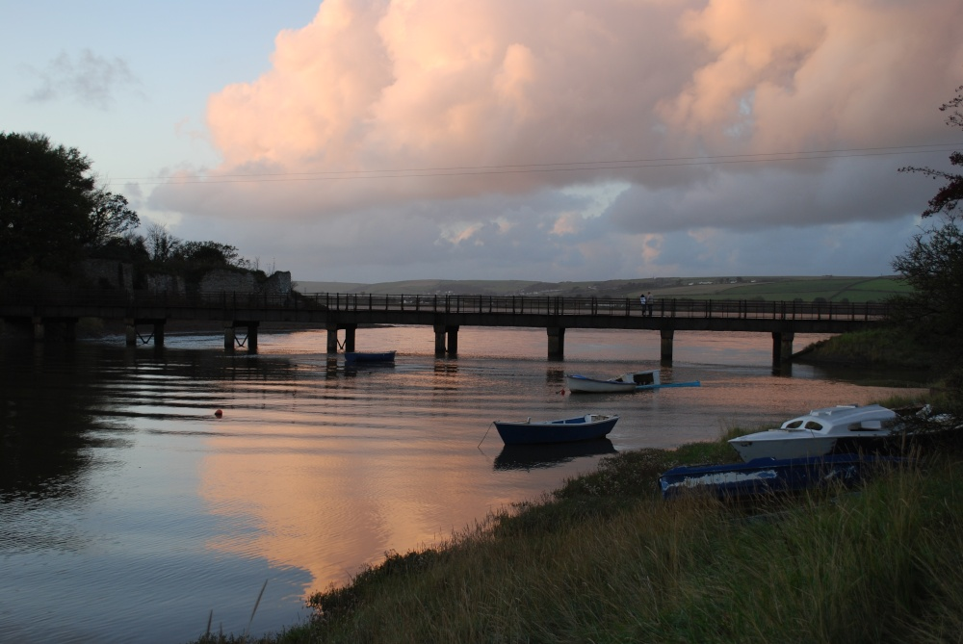

**Fremington Coastal Community Team** ***Economic Plan***

January 2016

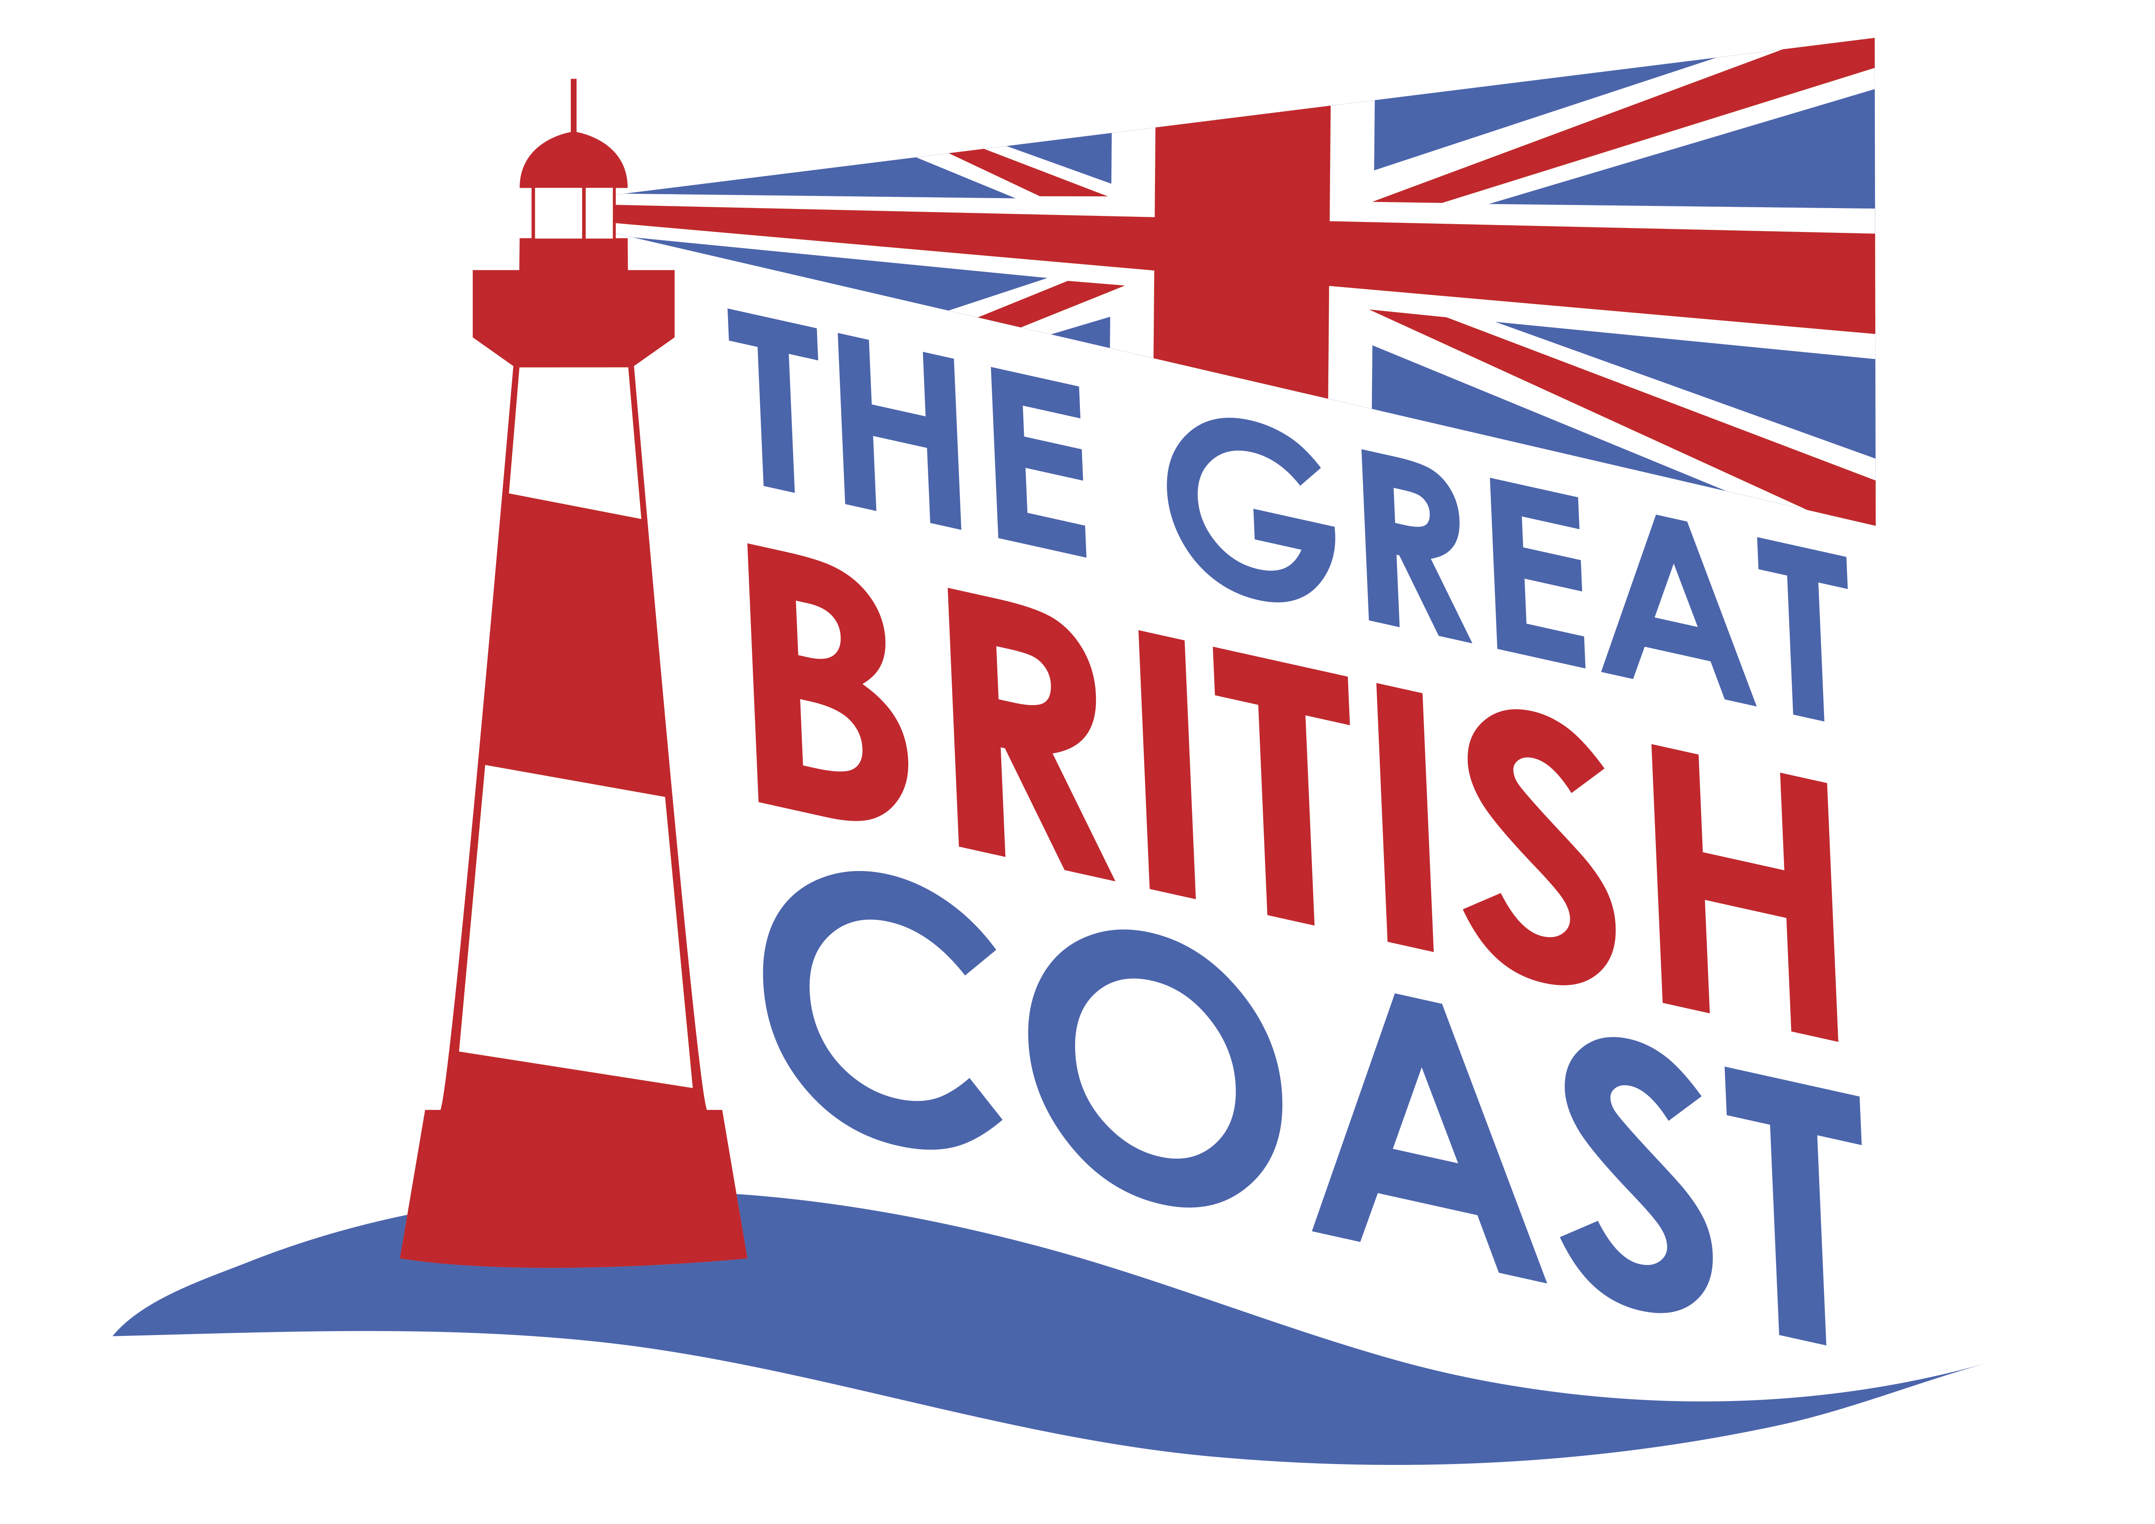

1. **Purpose**

The purpose of this document is to outline an economic plan for the development of the visitor economy within Fremington centred on the significant heritage and environmental assets in and around the historic Fremington Quay. It is a strategy to support the creation of sustainable new businesses and jobs, which are greatly needed within the area, by safeguarding and enhancing the community’s core attractions. This plan has been prepared by the Fremington Coastal Community Team (CCT), which has come together for this purpose and reflects a shared understanding of the key priorities and projects required to deliver these aims.

1. **Context** 
   1. ***The local area***

The North Devon community of Fremington (parish pop. c.10,500) is located 1.2km inland from the Taw estuary between the main towns of Barnstaple and Bideford (see Fig. 2.1) and originally grew up around the Manor House and parish church of St. Peter, both of which are now Grade II* listed buildings. The area is noted especially for its high quality environment and biodiversity, located within the North Devon UNESCO Biosphere Reserve. The Taw/Torridge estuary is a Site of Special Scientific Interest (SSSI), whilst Fremington Pill is a designated Local Nature Reserve. Fremington Quay lies at the confluence of the Taw Estuary and Fremington Pill and forms a locally important destination for visitors using the South West Coastal Path and Tarka Trail National Cycle Route.

The main economic focus for the community was once the Taw Estuary, the site of historic Fremington Quay, which until the mid 20th Century was a working port. It is likely that Fremington Quay and Fremington Pill were both used for landing and docking for centuries, both formally and informally; however, construction of the current Quay commenced in 1838 to provide deep-water loading facilities with a horse-drawn rail link to Barnstaple (soon upgraded to steam power and later joined to the wider passenger rail network). By the mid 19th Century, Fremington Quay had become the most important port between Bristol and Land's End. The main export was ball clay, primarily into Europe from geologically unique boulder clay deposits in the area. Fremington also had a strong pottery heritage, exporting to the New World and was the site of the internationally important Fremington Pottery, established by George Fishley in 1865. The main imports landed at the Quay were coal and limestone, and there are a number of lime kilns on the site. During World War 2 over 88,000 tons of coal was unloaded here for use across North Devon. Since then, however, the port declined as larger ships could not navigate the estuary, which was silting up. The last passenger train ran in 1965, with some goods trains running until 1982, when the Quay was left redundant.

Today Fremington is linked to Barnstaple and Bideford by road and bus, and by the Tarka Trail and South West Coast Path. The village does provide some local shopping, education, health and community facilities, but for employment opportunities, comparison shopping, further/higher education and leisure services, residents typically travel to Barnstaple or Bideford.

Much of the historic infrastructure of Fremington Quay still remains and now comprises a Heritage Centre, the old railway station (occupied by an award winning café), lime kiln, water tower, the old quay promenade, the adjacent Fishley Quay, Penhill Promontory walk, a cycle hire business and a popular play area (see Fig. 2.2). A designated Conservation Area (10.4 ha) protects the industrial heritage of the Quay; however, vehicular access, along a 1.3km single track road, and parking (space for c.40 cars in winter with an extension in summer for an additional 22 cars) are both limited. Most visitors to the Quay arrive on foot or by cycle along the Tarka Trail National Cycle Route, which follows the course of the old railway line (over 60,000 cyclists passed through the Quay area in 2010). The Quay is also popular with families (for shorter walks along the Tarka Trail) and for quayside fishing year-round, and is noted as one of North Devon’s ‘string-of-pearl’ attractions along the Tarka Trail, with others (e.g. Johns of Instow/Appledore). Subject to upgrading, the Quay could still offer landing facilities for commercial and leisure use and there is potential to develop the maritime sector through proposed new employment land allocations nearby.

Ad hoc projects have done well to try to address some of the main constraints facing the Quay over the years, but there is a pressing need for a joined up, inclusive plan to enable Fremington and Fremington Quay to realise their full potential and to deliver significant economic, social and environmental benefits for the area.

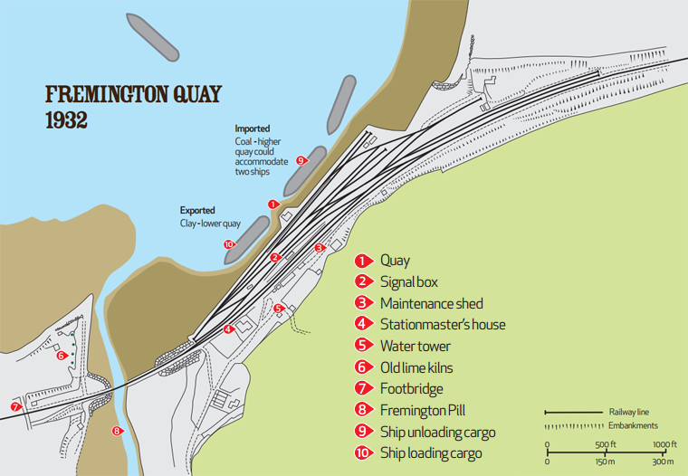



***Figure 2.2* Fremington Quay 1932**

***Figure 2.1* Fremington – focus of the plan**

Source: fremingtonquay.co.uk

y

* 1. ***Community context***

Fremington falls within the wider Barnstaple town area, to which it looks for key health, education, leisure and public administration services, and alongside Bideford for comparison goods shopping, and for employment of many of its residents. The village itself offers only limited community, shopping and leisure facilities, with direct road and public transport links through to Barnstaple and Bideford. With a distinct village character, proximity to the estuary and Tarka Trail, and housing prices below the average for North Devon district, Fremington has become a popular location for retirement and has an age profile higher than the district as a whole. Within the latest draft of the Local Plan, a significant level of new housing is proposed within the parish to help meet the district’s anticipated needs.

Notable community characteristics highlighted within a ‘Fremington Village Study’[1], prepared to support community-focused consultation to inform the Joint North Devon and Torridge Core Strategy, included the following (see Section 5 for supporting evidence):

* A rising population, growing faster than other Devon towns, and substantially older than the wider area.
* Income levels comparable to the average for North Devon district.
* A low level of dependency on benefits*.*
* Unemployment levels low, compared to the rest of North Devon.
* House prices lower than average for the district.
* A substantial supply of housing land is available to meet future housing needs.
* Significant amounts of employment land within the parish at Roundswell, which serves the wider Barnstaple area
* Low levels of deprivation for most measures.
* Despite an ageing population profile, residents are generally in good health with a lower incidence of long-term illness than the district or county.
* Limited capacity within primary and secondary schools serving the area for future growth.
* A limited range of community facilities, although much wider facilities are available in the towns of Barnstaple and Bideford.
* Good bus transport links to Barnstaple and Bideford, and cycling and walking routes through the Tarka Trail and South West Coast Path.
  1. ***The local economy***

At the last census, the main sectors for employment were retail, health and manufacturing, although most of these jobs were outside of the village. In 2001, only a quarter of Fremington’s working age residents worked within the parish, the majority of whom worked at Roundswell, an extensive retail, commercial and industrial estate development serving the wider Barnstaple area, quite separate from the village, but still falling within the same parish (less than 2 miles away). Data is not available for the number of businesses within the village itself, which are largely confined to local retail and services, including four care homes and some limited holiday accommodation. Consequently, Fremington currently offers little employment diversity, although land adjacent to nearby Yelland Quay (20 ha) within the parish has been earmarked for marine-related employment uses (see Section 2.4) and which highlights the potential for a re-emergence of the maritime economy within the area.

At the last census, unemployment was in line with the district average and 1 in 8 residents (12.4%) were self-employed, which is high in national terms (national average 10.4%), reflecting a general lack of large employers within the wider North Devon economy, but low compared to the district average (15.8%). The influence of Barnstaple as the sub-regional centre and its importance for employment is very strong.

Whilst North Devon as a whole is a popular tourism destination, and attractions such as the Tarka Trail and the South West Coast Path are significant draws, Fremington has a very limited tourism economy, with very few tourism-related businesses within the village - within Fremington and Yelland combined, there are only 3 B&Bs. At the last census, only 7.2% of residents within Fremington ward worked within the ‘accommodation & food services’ sector, compared to 9.8% within the district, and most of those would typically have been in employment outside of the village.

A key challenge and focus for this plan is how we will maximise the tourism potential of Fremington Quay as a significant heritage and environmental asset to increase both visitor and community value and as a basis for economic growth and employment within the ward?

* 1. ***Related initiatives***

Other local projects and initiatives that are relevant to this Plan include:

* **Protected landscape designations** – Fremington is located within the ***North Devon UNESCO Biosphere Reserve***, which is focused on the internationally important sand dunes system at Braunton Burrows and extends across the catchments of the rivers Taw and Torridge (see Fig. 2.3). Fremington falls within the ‘buffer zone’ of the Biosphere Reserve where the vision is for “*careful management of natural and cultural resources that ensures that communities can enjoy access to the natural environment and a cultural landscape maintained by local people.”*

[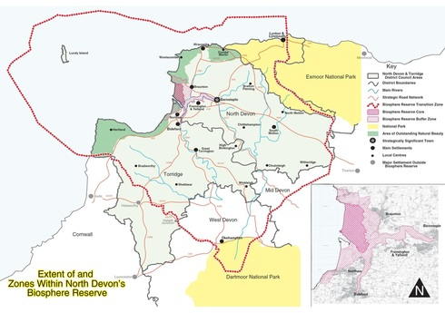](http://www.northdevonbiosphere.org.uk/uploads/1/5/4/4/15448192/_6903360_orig.jpg)

* **Tarka Trail & South West Coast Path** – the Tarka Trail is one of the country's longest continuous traffic-free walking and cycling paths, and directly passes the Fremington Quay site. The café and Heritage Centre are destinations in their own right and a significant attraction and stopping point along the route. The Trail is very popular and forms part of the ***National Cycle Network*** and the ***Devon Coast to Coast Cycle Route***. Between Barnstaple and Bideford, the Trail also provides the route of the South West Coast Path. In 2014, over 0.75 million ‘cycle passes’ were recorded by counters along the route of the Trail.

***Figure 2.3* North Devon Coast AONB & North Devon Biosphere Reserve**

* **Development sites** – there are important development sites within Fremington parish which will impact upon the village. Proposals within the North Devon & Torridge Joint Local Plan (publication draft) (2014) include the provision of 426 new homes within the parish and the redevelopment of Yelland Quay, which is to the west of Fremington Quay. Around 275 homes are planned on a redeveloped ***Fremington Army Camp*** site, which is separated from Fremington Quay by Fremington Pill and is adjacent to a Local Nature Reserve. Proposals include sports pitches, community facilities and foot and cycle access to the Tarka Trail. Two sites are proposed for new employment land at ***Yelland Quay*** (20 ha combined), including a site adjacent to the quay and to the Tarka Trail for marine-related economic development or infrastructure provision requiring a waterside location.

1. **Methods**
   1. ***About the Coastal Community Team***

This Plan has been developed by the Fremington Coastal Community Team (CCT) as an action plan for development of the visitor economy focused on the community’s main visitor asset, Fremington Quay. The CCT is led by Fremington Quay Environment Group, whose aim is *‘to promote new environmental projects, and enhance the natural amenities within the parish’*, supported by North Devon Council. The CCT is a new forum and represents the range of interests in the Quay.

Represented on the CCT are:

Fremington Quay Environment Group

Museum of Barnstaple & North Devon

Fremington Parish Council

Devon Waste Management

The Gaia Trust

North Devon Council

Fremington Quay Café

North Devon Biosphere

Appledore/Instow Ferry

* 1. ***How our Plan was developed***

We have developed our plan over a number of working meetings and workshops to (a) agree upon the focus, scope and scale of ambitions of our plan; (b) to recognise the issues, strengths, weaknesses, opportunities and threats faced by our community in developing the visitor economy, focused on the potential of Fremington Quay and the high quality environment; and (c) to develop the project ideas that together will deliver the benefits that our community is looking for. This work has highlighted four key priorities for our plan which have structured our thinking:

* Developing the heritage value of Fremington Quay – targeted projects to enhance the core heritage attraction at Fremington Quay.
* Developing the environmental attraction – initiatives to increase visitor awareness, enjoyment and experience of the high quality natural environment around Fremington Quay and linking with the attraction of the North Devon Coast AONB and the North Devon UNESCO Biosphere Reserve, which have national and international value and recognition.
* Increasing diversity of access to the Quay – addressing the main barrier to development of the visitor economy related to Fremington Quay - public awareness and access to the quay for all users, whether approaching from the land or the sea.
* Business opportunities – supporting and developing tourism-related economic activity on-site and within the village to increase growth and employment.

This Plan has been subject to consultation with the wider community, which has been undertaken through a workshop event.

1. **Our Plan – aims & objectives**

**Our vision** is for a developed and environmentally sustainable visitor economy within Fremington centred on the heritage attraction of Fremington Quay and the high quality environment that benefits the community through new opportunities for businesses, jobs, and leisure and recreation.

**The aim of our Economic Plan** is to develop the visitor economy in Fremington for the benefit of businesses, residents and visitors alike, whilst protecting and enhancing the high quality heritage and environmental assets, upon which it depends, to meet visitor and community needs.

Our key **objectives** are:

* To diversify the Fremington economy, by increasing the contribution of tourism.
* To increase visitor capacity, reduce dependence on car access, maximise use of walking trails, and improve the offering at Fremington Quay.
* To improve cycle connections to and from the village from the quay.
* To safeguard and enhance the heritage and natural environmental assets of Fremington Quay and its estuary position.
* To increase the number, and broaden the range, of visitors to Fremington Quay and to the Fremington area.
* To increase year-round business and employment opportunities within the village, particularly for young people.
* To increase opportunities for recreation and leisure at Fremington Quay for visitors and residents alike.
* To maximise the use of the estuary and marine setting.
* To increase travel to Fremington Quay other than by car, including improvements to the local footpath network.
* To improve facilities to encourage access to green space and the estuary.

1. **Community needs and supporting data**

***Demography*** – an increasing and aging population, rising more quickly than the district and the county as a whole:

* In 2011, Fremington Ward, which includes the neighbouring village of Yelland, had a population of 4,310[2].
* Between 2001 and 2010, the Parish’s population increased by 4.7%, which was lower than experienced across other North Devon towns (4.9%) (Barnstaple, Braunton, Ilfracombe and Braunton) but higher than across the district (4.3%) as a whole and across Devon (3.7%).
* The demographic profile of the ward is older than the district as a whole. At the last census:
  + - The average age of residents within the ward was 48.1 years, compared to 43.3 within North Devon district and 39.3 nationally.
    - Only 40.7% of residents were aged below 45 years, compared to 49.4% within the wider district and 58.3% nationally.
    - Almost one third of residents (31.1%) were aged 65 or over, compared to only 22.2% within the district and 16.4% nationally – Fremington is a popular area for retirement.
* By 2033, over one quarter of the population in the South West is projected to be aged 65 and over, a level already reached in Fremington and being approached across North Devon[3].

***Income*** – income levels are comparable to the average for North Devon, with low levels of dependency on benefits:

* In 2008, average household income within Fremington & Yelland was £24,204 p.a., just 3% below the district average of £24,970 and a county average of £26,112[4].
* In 2011, only 3.4% of 16-59 year olds within the parish were claiming Income Support, compared to 3.9% across the district, 3.4% across the county and 4.8% nationally.
* At an average of £202,492 in 2011, house prices within the parish were lower than the district (£216,673) and Devon averages (£233,819) but 29% higher than the national average (£161,281)[5].
* More than three quarters of households (79%) within the Fremington Rural electoral area were owned outright (with or without a mortgage), compared to an average of 68% across the district and 70% across the county. Only 2% of households had no central heating, compared to a district and county average of 5%.
* Car ownership in the Fremington Rural area (88% of all households owning at least one vehicle) is higher than across the district (81%) and the county (83%).
* Levels of deprivation are low for most measures, with Fremington ward showing below average deprivation in respect of employment, income, health and disability, skills and training[6].

***Economic activity*** – the area’s profile reflects that of the wider district. Fremington benefits from proximity to Barnstaple, forming part of the sub-regional centre for northern Devon:

* At the last Census, 79.2% of working age residents were economically active, in line with the district average (79.6%) and the national average (76.8%).
* Almost two thirds (62.6%) of working age residents were employees, higher than the district average (59.7%) and national average (60.6%), reflecting the importance of nearby Barnstaple for employment.
* 1 in 8 working age residents (12.4%) were self-employed, which is high compared to the national average (10.4%), but low in comparison to the wider district (15.8%).
* At 5.4%, unemployment was in line with the district average (5.2%), but lower than the national averages (7.6%).
* A total of 8.9% of all residents were retired, higher than both the district average (6.4%) and the national average (4.9%), reflecting the area’s popularity as a location for retirement.
* In 2015, only 0.2% of 15-64 years olds within the ward were claiming Job Seekers Allowance, compared with 0.8% within the district, and 1.5% within Great Britain[7].

***Employment*** – key employment sectors are retail, manufacturing and health:

* At the last census, the main sectors for employment were retail (employing 19.6% of residents aged 16 to 74); health (15.9%) and manufacturing (10.8%), which is in line with the wider district profile.
* Tourism is important to the wider economy (see below), but only 7.2% of residents within Fremington ward worked within the ‘accommodation & food services’ sector, compared to 9.8% within the district.

***Tourism activity*** – potential to develop the visitor economy:

* Tourism is important to the North Devon economy. In 2013, tourism in North Devon generated[8]:
  + - 981,000 staying visitor trips
    - 3.2 million day visits
    - £357.6 million direct visitor spend
    - Supported over 7,000 jobs
* Figures are not available for the value of the visitor economy to Fremington village alone, but ‘traffic’ data for the Tarka Trail cycleway, provides an indication of the number of visitors.
  + - In 2002, under 40,000 ‘cycle passes’ were registered on the Tarka Trail by automatic counters at Fremington Quay, not including walkers and runners.
    - In 2014, over 100,000 ‘cycle passes’ were recorded, which represents more than 250% growth over the period.
* Within the village itself, however, there is relatively little tourist accommodation. In Fremington and neighbouring Yelland there are only 3 B&Bs, 3 cafes and 3 restaurants. A key challenge for this Economic Plan is how the tourism potential of the area can be best leveraged for the economic and social benefit of the village and its residents.

***Community issues*** - incomes, activities for young people and housing affordability are amongst the main issues identified by the community:

* Within a 2008 ‘Place Survey’ undertaken by Devon County Council, the top 5 rated things that the community identified as most needing improvement in the area were:
  + - Wage levels and local cost of living (58%)
    - Activities for teenagers (45%)
    - Affordable decent housing (42%)
    - Job prospects (39%)
    - Public transport (29%)

1. **SWOT analysis of the Fremington Quay visitor economy**

|  |  |
| --- | --- |
| **Strengths** | **Weaknesses** |
| * Location fronting Taw Estuary * High quality built environment * High quality natural environment * Fremington Quay Heritage centre * Award-winning café * Proximity to the Tarka Trail traffic-free cycle trail * Accessibility by local footpath network * Proximity to the South West Coast Path * Part of the North Devon UNESCO Biosphere Reserve * Close to the North Devon Coasts AONB * History of clay exports * Internationally recognised Art Pottery tradition | * Distance from the centre of the village (0.8 miles) * Poor single-track access from the main road * Limited parking * Not readily accessible by public transport * Low visitor awareness of the attraction * Passing cyclists and walkers do not stay long – used as a stopping off point * Poor access to the river from the quay * The riverfront is underutilised * Limited places to stay in Fremington * Limited tourism-related businesses in Fremington * Limited toilet facilities * No all-weather cover * Would need additional catering capacity if visitor numbers grew |
| **Opportunities** | **Threats** |
| * Create more things for visitors to do – develop the proposition * Wildlife watching facilities * Promote geology-tourism * Information and interpretation materials * Develop links with the AONB and Biosphere Reserve * Water-based activities – sailing, canoeing, kayaking, * Increase access for leisure boats * Increase the size of the car park * Improve disabled facilities * Develop ferry access from Barnstaple, Bideford, Instow, Braunton * Schools and educational markets * Green Infrastructure * Become the ‘Gateway to Fremington’ * Lime Kilns | * Effects of prolonged economic downturn * Limited ability to easily increase car access to the site * Competing development uses of nearby sites – potential to impact upon the core attraction * Lack of critical mass of tourism-related businesses in the village * Availability of funding/investment * Private sector confidence * Sewerage infrastructure capacity |

1. **Our priorities**

Our plan priorities reflect the focused aim of our plan and the identified strengths, weaknesses, opportunities and threats within our visitor economy:

| ***Priority*** | ***Rationale*** | ***What we want to achieve*** |
| --- | --- | --- |
| 1. **Developing the heritage value of Fremington Quay** | Projects to safeguard and enhance the quality and range of the core heritage visitor offering at Fremington Quay, the main reason for visiting e.g.   * Enhancement of the Lime Kiln as part of the Quay complex * Restoration of Fishley Quay * Creation of pottery using Water Tower | **Long term goal:** enhancement of the heritage buildings and site as a core attraction for visitors  **Long term measures (beyond 5 years):**   * Water Tower refurbishment complete with space let to potter * Fishley Quay accessible * Lime Kilns accessible to the public (working in partnership with third party owner) |
| 1. **Developing the environmental attraction** | Initiatives to safeguard the high quality natural environment and increase visitor awareness, enjoyment and experience of it at Fremington Quay e.g.   * New wildlife watching facilities * Wildlife safaris * Enhanced links to the AONB and Biosphere Reserve * Schools and educational tours | **Goals:** strengthened links with the Biosphere and new environmental attractions in place **(ST);** wildlife cameras **(MT)**  **Short term measures (within 6 mths):**   * Evidence of improved links with Biosphere * New tours/safaris   **Medium term measures (within 5 years):**   * Number of cameras installed to view wildlife |
| 1. **Increasing access to the Quay** | Addressing the main barrier to development of the visitor economy related to Fremington Quay - public awareness and access to the quay for all users e.g.   * Improving access to the Quay by means other than the car * Enhancing disabled access * Increasing river usage and access, restoring life to the estuary and creating a gateway for waterborne access * Signage | **Goals:** improved signage **(ST)**;new signage, improved landing facilities, trail strategy, disability access (**MT**); improvements to road access, ferry links (**LT**)  **Short term measures (within 6 mths):**   * Sign strategy agreed * Sign designs agreed   **Medium term measures (within 5 years):**   * Number of new signs installed * Number of new visitors arriving by water * Trail strategy delivered * Disability access audit completed   **Long term measures (> 5 years):**   * Improvements to road access and parking * Instow/Appledore Ferry (or alternative) including Fremington in its timetable |
| 1. **Increasing business opportunities** | Developing tourism-related economic activity on-site and within the village, linked to the development and enhancement of Fremington Quay to increase growth and employment opportunities e.g.   * Things to do * Places to stay * Improved visitor facilities * Increased capacity for the café * Pottery with sales area | **Goals:** a masterplan showing potential reconfiguration of accommodation **(ST)**;improvements to visitor facilities in accordance with masterplan (**MT**); improvements to road access, ferry links (**LT**)  **Short term measures (within 6 mths):**   * Masterplan delivered   **Medium term measures (within 5 years):**   * Reconfiguration of facilities to maximise use of space * Sewage system improved in partnership with the EA * Toilet facilities improved LT Measures (> 5 years)   **Long term measures (> 5 years):**   * Extension to existing café to provide increased capacity |

1. **Our plan**
   1. ***Developing the heritage value of Fremington Quay***

|  |  |  |  |  |
| --- | --- | --- | --- | --- |
| **Key project (title)** | **What it will deliver (type of outcomes & outputs) SMART** | **Who will lead & key partners** | **Estimated cost** | **Possible funding streams** |
| HV1. **Fishley Quay** | Increased and longer visits, increased visitor expenditure, leading to increased employment | CCT, NDC, Historic England | TBC | HLF, CCF |
| **Description & rationale:**  Repair and restore the historic Fishley Quay, part of the Fremington Quay site, for heritage and leisure uses, and incorporate into the overall Fremington Quay complex. This project will increase the range of heritage attractions on show and provide additional critical mass for a day visit destination. Fishley Quay was used by the Fishley Holland art pottery dynasty. | | **Resources required to deliver** | Project management  Funding  Bid writing | |
| **Next steps & dates** | Heritage survey and condition report  **Long-term** activity (> 3years) | |

|  |  |  |  |  |
| --- | --- | --- | --- | --- |
| **Key project (title)** | **What it will deliver (type of outcomes & outputs) SMART** | **Who will lead & key partners** | **Estimated cost** | **Possible funding streams** |
| HV2. **Fremington Lime Kilns** | Longer visits, increased visitor expenditure, leading to increased employment | CCT, NDC, Historic England, third party owner | TBC | HLF, CCF, Leader 5 |
| **Description & rationale:**  Explore potential to use the Lime Kilns and use it to mark the heritage of the area. Add to the heritage value of Fremington Quay to create additional things to see and explore on site. | | **Resources required to deliver** | Project management  Funding  Bid writing | |
| **Next steps & dates** | Heritage survey and condition report  **Long-term** activity (> 3years) | |

|  |  |  |  |  |
| --- | --- | --- | --- | --- |
| **Key project (title)** | **What it will deliver (type of outcomes & outputs) SMART** | **Who will lead & key partners** | **Estimated cost** | **Possible funding streams** |
| HV3. **Water Tower Restoration** | Longer visits, new business premises, increased visitor expenditure, increased employment | CCT, NDC, Historic England, third party owner | TBC | HLF, CCF, Leader 5 |
| **Description & rationale:**  Restoration works to the historic water tower to enhance the heritage value of the site and create new premises for an alternative economic use, adding an additional visitor attraction e.g. studio and sales space for a potter, linking with the history of ball clay exports from the Quay. | | **Resources required to deliver** | Project management  Funding  Bid writing | |
| **Next steps & dates** | Heritage survey and condition report  **Long-term** activity (> 3years) | |

* 1. ***Developing the environmental attraction***

|  |  |  |  |  |
| --- | --- | --- | --- | --- |
| **Key project (title)** | **What it will deliver (type of outcomes & outputs) SMART** | **Who will lead & key partners** | **Estimated cost** | **Possible funding streams** |
| ENV1. **Wildlife Watching** | Increased attractions, increased visits, longer stays, increased expenditure, leading to increased employment | CCT, Biosphere Reserve, AONB, Devon Wildlife Trust, RSPB | TBC | Leader 5, AONB Sustainable Dev Fund |
| **Description & rationale:**  Create new opportunities to view wildlife in and around Fremington Quay to provide and promote new reasons to visit, particularly for families. Project initiatives include:   1. Create bird hides and bird-watching resource packs (short-term) 2. Develop a series of expert-led wildlife safaris (short-term) 3. Install bat and bird cameras to enable visitors to view (short-term) 4. New recreational fishing competitions (short-term) | | **Resources required to deliver** | Project management and co-ordination | |
| **Next steps & dates** | Form project group, develop proposals, consultation  Potential **QUICK WIN** (within 12 mths) | |

|  |  |  |  |  |
| --- | --- | --- | --- | --- |
| **Key project (title)** | **What it will deliver (type of outcomes & outputs) SMART** | **Who will lead & key partners** | **Estimated cost** | **Possible funding streams** |
| ENV2. **Biosphere Reserve** | Longer visitor stays, increased expenditure, leading to increased employment | CCT, Biosphere Reserve, AONB | TBC | Leader 5 |
| **Description & rationale:**  Promote links with the Biosphere Reserve to provide a gateway for information and education through the Heritage Centre – communicate reasons for visitors to stay longer in the area and to explore further the wider range of environmental and heritage attractions | | **Resources required to deliver** | Project management and co-ordination | |
| **Next steps & dates** | Scope and agree the linking opportunities, draw up plan to implement  **Short-term** activity (within 12 mths) | |

|  |  |  |  |  |
| --- | --- | --- | --- | --- |
| **Key project (title)** | **What it will deliver (type of outcomes & outputs) SMART** | **Who will lead & key partners** | **Estimated cost** | **Possible funding streams** |
| ENV3. **Educational Tours** | Increased visits, stays and expenditure, leading to increased employment | CCT, Biosphere Reserve, AONB, schools, colleges | TBC | HLF, Leader 5, AONB Sustainable Dev Fund |
| **Description & rationale:**  Target new and regular potential visitor markets to increase visitors to the Quay. Using the natural environment and ecology, develop a range of educational tours that cater for schools, colleges and other visitors that promote the uniqueness of the area, developing and using resources such as Home Farm Marsh | | **Resources required to deliver** | Project management, collation of resources, design of tours, match funding | |
| **Next steps & dates** | Form working group  **Short-term** activity (within 12 months) | |

* 1. ***Increasing access to the Quay***

|  |  |  |  |  |
| --- | --- | --- | --- | --- |
| **Key project (title)** | **What it will deliver (type of outcomes & outputs) SMART** | **Who will lead & key partners** | **Estimated cost** | **Possible funding streams** |
| ACC1. **River Ferry** | New attraction, increased visits and footfall, increased expenditure, leading to increased employment | Private operator, CCT | TBC | Leader 5 |
| **Description & rationale:**  Develop a river ferry link to the Quay from key locations to increase direct footfall and underline Fremington Quay as a destination visit e.g. to and from Instow, Braunton, Barnstaple, Appledore. There is potential to link with the existing Instow ferry. The ferry itself could become an attraction in its own right. | | **Resources required to deliver** | Private sector engagement, feasibility appraisal, funding | |
| **Next steps & dates** | Private sector engagement  **Long-term** activity (>3 years) | |

|  |  |  |  |  |
| --- | --- | --- | --- | --- |
| **Key project (title)** | **What it will deliver (type of outcomes & outputs) SMART** | **Who will lead & key partners** | **Estimated cost** | **Possible funding streams** |
| ACC2. **Landing Facilities** | New attractions, increased visits, longer stays, increased expenditure, increased opportunities for healthy exercise , leading to increased employment | CCT, NDC | TBC | Leader 5 |
| **Description & rationale:**  Improve the river landing and launching facilities at the Quay (e.g. pontoon access) to attract new waterborne visitors and provide new opportunities for participating in watersports from the Quay, including small boats, sailing boats, canoes, kayaks, gig boats. A key emphasis is restoring river activity and creating a ‘Gateway to Fremington’ for visitors arriving by river. | | **Resources required to deliver** | Project management, options appraisal, consultation, funding | |
| **Next steps & dates** | Form working group  **Medium-term** activity (1-3 years) | |

|  |  |  |  |  |
| --- | --- | --- | --- | --- |
| **Key project (title)** | **What it will deliver (type of outcomes & outputs) SMART** | **Who will lead & key partners** | **Estimated cost** | **Possible funding streams** |
| ACC3. **Trail Strategy** | Increased access to the site, increased visits to the village from the Quay, reduced car travel, longer visits | CCT | TBC | Leader 5 |
| **Description & rationale:**  Develop a Trail Strategy and Masterplan to provide for a range of access options to and from the Quay, linking to the village, planned new housing development and Tarka Trail; and covering walking, cycling and Tramper Trails as part of a local Green Infrastructure Strategy. | | **Resources required to deliver** | Project management, options appraisal, consultation, funding | |
| **Next steps & dates** | Form working group  **Medium-term** activity (1-3 years) | |

|  |  |  |  |  |
| --- | --- | --- | --- | --- |
| **Key project (title)** | **What it will deliver (type of outcomes & outputs) SMART** | **Who will lead & key partners** | **Estimated cost** | **Possible funding streams** |
| ACC4. **Road Access & Parking** | Increased visits, stays and expenditure, leading to increased employment | CCT, NDC, DCC | TBC | TBC |
| **Description & rationale:**  Enable increased car and pedestrian visits from Fremington village (and via bus links from Barnstaple and Bideford ) through improvements to the narrow access road and a separate walking area/route for pedestrians, the creation of a new parking area, and potential relocation of the cycle hire facility. | | **Resources required to deliver** | Project management, funding, traffic appraisal, technical survey | |
| **Next steps & dates** | Identify key implementation stages with public sector partners  **Long-term** activity (> 3 years) | |

|  |  |  |  |  |
| --- | --- | --- | --- | --- |
| **Key project (title)** | **What it will deliver (type of outcomes & outputs) SMART** | **Who will lead & key partners** | **Estimated cost** | **Possible funding streams** |
| ACC5. **Improved Signage** | Increased visits, stays and expenditure, leading to increased employment | CCT, NDC, DCC | TBC | Leader 5 |
| **Description & rationale:**  Improve signage to Fremington Quay from key road, foot and cycle access routes to raise awareness of the heritage attraction, increase likelihood of visits, and encourage journeys to the village from the Quay. | | **Resources required to deliver** | Project management time, funding | |
| **Next steps & dates** | Audit of access routes and key signage needs  Potential **QUICK WIN** (within 12 months) | |

|  |  |  |  |  |
| --- | --- | --- | --- | --- |
| **Key project (title)** | **What it will deliver (type of outcomes & outputs) SMART** | **Who will lead & key partners** | **Estimated cost** | **Possible funding streams** |
| ACC6. **Disabled Access** | New visitor markets, Increased visits, stays and expenditure, leading to increased employment | CCT | TBC | TBC |
| **Description & rationale:**  Improve and promote disabled access to the Quay area to overcome barriers to visiting, building on existing visits to the café. Potential for special tracks for disabled vehicles and a network of tramper accessible paths. | | **Resources required to deliver** | Access assessment, funding to make improvements, promotional material | |
| **Next steps & dates** | Disability access audit  **Medium-term** (1-3 years) activity | |

* 1. ***Increasing business opportunities***

|  |  |  |  |  |
| --- | --- | --- | --- | --- |
| **Key project (title)** | **What it will deliver (type of outcomes & outputs) SMART** | **Who will lead & key partners** | **Estimated cost** | **Possible funding streams** |
| BUS1. **Site Masterplan** | Increased visitor satisfaction, new visitor attractions, increased and longer visits, increased expenditure leading to increased employment | CCT | TBC | Leader 5 |
| **Description & rationale:**  Review, rationalise and reconfigure how the Fremington Quay site works as a visitor attraction incorporating planned future new uses to identify opportunities for improvement and development e.g. moving the current cycle hire location to free up other options, space for events and activities. | | **Resources required to deliver** | Project co-ordination, funding, external expertise | |
| **Next steps & dates** | Bring together working group, appoint consultant  Potential **QUICK WIN** (within 12 months) | |

|  |  |  |  |  |
| --- | --- | --- | --- | --- |
| **Key project (title)** | **What it will deliver (type of outcomes & outputs) SMART** | **Who will lead & key partners** | **Estimated cost** | **Possible funding streams** |
| BUS2. **Outdoor Activities & Events** | New visitor markets, increased visits, stays and expenditure | CCT, private sector operators, arts and music agencies, Biosphere, AONB | TBC | Leader 5 Bus Grant Scheme (for individual business applicants), arts funding |
| **Description & rationale:**  Broaden the range of activities available at Fremington Quay to attract new visitor markets. New visitor activities could include, for example, geological interest tours, watersports, adventure golf, events, festivals, arts, music, wildlife watching, photography trails – mix of agency and private sector delivered activities | | **Resources required to deliver** | Project co-ordination, funding | |
| **Next steps & dates** | Bring together working group  Mix of potential **short** (within 12 months) **or medium-term** (1-3 years) activities | |

|  |  |  |  |  |
| --- | --- | --- | --- | --- |
| **Key project (title)** | **What it will deliver (type of outcomes & outputs) SMART** | **Who will lead & key partners** | **Estimated cost** | **Possible funding streams** |
| BUS3. **Somewhere to Stay** | New reasons to visit, longer stays, increased expenditure | CCT, landowners, Planning Authority, Biosphere | TBC | Leader 5 Bus Grant Scheme (for indiv business applicants) |
| **Description & rationale:**  To address the limited amount of tourist accommodation within the village and their physical distance Fremington Quay, this project would seek to create new forms of ‘low impact’ and temporary accommodation on, or close to, the Quay site for visitors (e.g. for schools, educational trips), as stop-off or destination accommodation e.g. camping, yurts, shepherd huts, railway carriages, wild camping | | **Resources required to deliver** | Project management | |
| **Next steps & dates** | Early discussion re. possibilities with the Planners  **Medium-term** activity (1-3 years) | |

|  |  |  |  |  |
| --- | --- | --- | --- | --- |
| **Key project (title)** | **What it will deliver (type of outcomes & outputs) SMART** | **Who will lead & key partners** | **Estimated cost** | **Possible funding streams** |
| BUS4. **Café & Visitor Centre** | Increased visitor expenditure, leading to new jobs | CCT | TBC | Leader 5 |
| **Description & rationale:**  Improve and expand visitor facilities on the Quay to support growth in the number of visitors, in particular the café/visitor centre facilities to support increased catering capacity, extended opening hours, Wi-Fi etc. | | **Resources required to deliver** | Project management, designs, planning application, funding | |
| **Next steps & dates** | Develop plans  **Medium-term** activity (1-3 years) | |

|  |  |  |  |  |
| --- | --- | --- | --- | --- |
| **Key project (title)** | **What it will deliver (type of outcomes & outputs) SMART** | **Who will lead & key partners** | **Estimated cost** | **Possible funding streams** |
| BUS5. **Sewerage System Improvements** | Enable new business opportunities and visitor activities, leading to new jobs | CCT, TDC | TBC | TBC |
| **Description & rationale:**  The sewerage system is currently at capacity and requires urgent improvement to support any new development or increased business and visitor activity on Fremington Quay. Without upgrading the sewage system, there will be a direct risk to the environment. | | **Resources required to deliver** | Project management, funding | |
| **Next steps & dates** | Develop plans, planning application  **Medium-term** activity (1-3 years) | |

|  |  |  |  |  |
| --- | --- | --- | --- | --- |
| **Key project (title)** | **What it will deliver (type of outcomes & outputs) SMART** | **Who will lead & key partners** | **Estimated cost** | **Possible funding streams** |
| BUS6. **Toilets** | Improved visitor facilities | CCT | TBC | Leader 5 |
| **Description & rationale:**  Improve the toilet facilities and include shower facilities to support watersports and overnight accommodation. | | **Resources required to deliver** | Project management, designs, planning application, funding | |
| **Next steps & dates** | Develop plans  **Medium-term** activity (1-3 years) | |

Abbreviations used:

AONB Areas of Outstanding Natural Beauty

CCF Coastal Communities Fund

CCT Coastal Community Team

CRF Coastal Revival Fund

HLFHeritage Lottery Fund

NDC North Devon Council

RSPB Royal Society for the Protection of Birds

1. **Barriers & risks to implementing our plan**

|  |  |
| --- | --- |
| **Identified barriers/risks** | **How we will manage/overcome** |
| 1. Securing funding for feasibility and development work in order to bid into funding opportunities | * Recognise that public funding is increasingly limited * Prioritise project work to focus on the most important project initiatives * Pooling of resources from the Team through partnership working * Where appropriate, work closely with the private sector to share resources and maximise value |
| 1. Obtaining planning permission for land use projects | * Early two-way engagement with the Local Planning Authority to assist understanding of aspirations and understanding of any planning constraints * Prioritise focus on areas of common agreement * Develop ongoing working relationship |
| 1. Delay or non-delivery of key projects | * Maintain CCT focus on the progress of key projects * All projects to have individual project owners, who report on progress |
| 1. Limited project management time | * Early dialogue with public sector partners to ensure awareness of our plans and aspirations and to prioritise focus in areas where they could help practically |
| 1. Tidal constraints | * Using the timetable for the ferry to work with the state of the tide and improved landing facilities to provide deeper water moorings |
| 1. Third party ownerships and negotiation on existing leases | * Relocation options being explored |
| 1. Sewage system improvements being delivered | * Working with the Environment Agency to arrive at realistic and deliverable solutions |

1. Devon County Council (2011)*Barnstaple Town Study Report: Core Strategy Evidence,* October 2011
2. Census 2011
3. ONS, 2010
4. CACI and Paycheck data provided by CACI 2008
5. Land Registry 2011
6. North Devon Council (2011) Fremington & Yelland Area Study
7. JSA, 2015
8. The South West Tourism Research Company