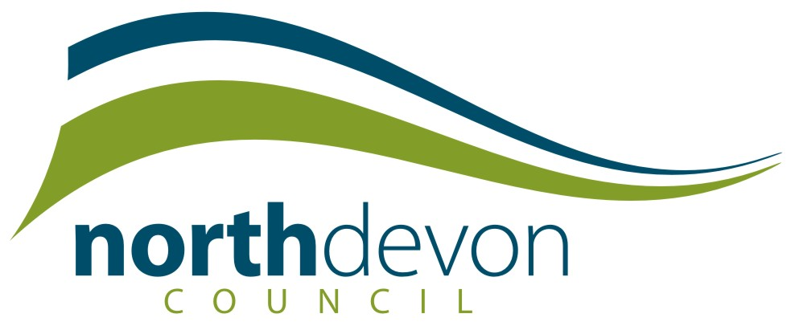

Community Right to Bid
Sensitive/Confidential Information

North Devon Council may provide information submitted as part of the nomination form to nominate an asset for inclusion on the lists of assets of community value to the owner (s) of the property concerned.

This form should be submitted with the nomination form, should you consider that any part of the nomination form or supporting documents contain sensitive information, such as confidential information or otherwise non-disclosable into the public domain.

Your title: | Forename: |  | Surname:
Address:

Postcode: |  | Tel:
Email address:

Name of organisation:

Name of nominated property:

Document/Information: | Page No. | Reason for non-disclosure and what harm would disclosure cause

You acknowledge that this form is of indicative value only. North Devon Council will take account of the above and consider your views, however the Council will make the final decision as to whether the information should be disclosed or not.

