- North Devon Council and Torridge District Council have adopted a Joint Inclusive Equality Scheme covering all 9 protected characteristics of equality.

On request we are produce documents in alternative formats e.g. Recycling leaflets in Polish and the Green Sweep Collection Calendar in large print.

For more information, please visit the Equality and Diversity pages on insite or at http://www.northdevon.gov.uk/council/strategies,-plans-and-policies/equality-and-diversity/

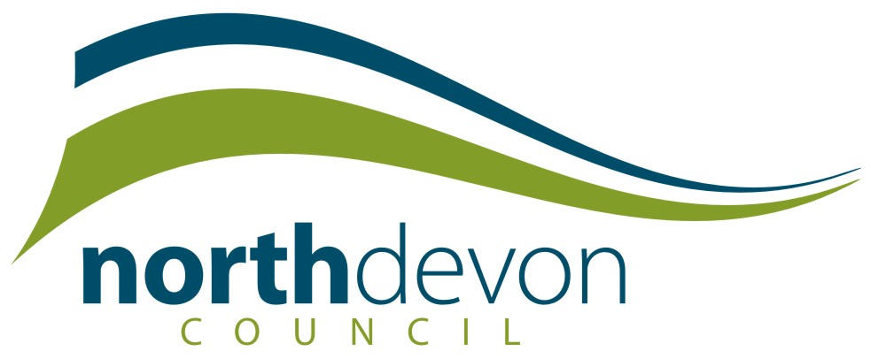

Equality and Diversity in
North Devon Council
‘There is strong commitment to improving the depth of understanding of equality and diversity across the spectrum for Members and Officers’

Comment made by the Peer Assessors assessing us against Level 3 of the Equality Standard

What is Equality & Diversity?

Equality is about creating a fairer society in which everyone has the opportunity to fulfil their potential.

Diversity is about recognising and valuing difference in its broadest sense.

There are 9 protected characteristics to equality –

Age Disability Religion/Belief

Marriage & Civil Partnership

Gender Gender Reassignment Race

Sexual orientation Pregnancy & Maternity

Equality & Diversity at NDC

Everyone is entitled to work in an organisation that treats all staff equally and values their differences.

North Devon Council is committed to promoting equality and diversity in all that we do, and to eradicating discrimination.

We aim to:

- Promote equality
- Challenge and eradicate prejudice and discrimination
- Respect and value diversity
- Promote tolerance
- Provide responsive, sensitive and accessible services and information
- Ensure our workforce reflects the diverse population of North Devon
- Develop a positive, supportive and anti- discriminatory working environment for all staff

So what are some of the ways NDC have implemented Equality & Diversity...So Far?

- North Devon Council has signed up to Equality Framework for Local Government. This is a framework for managing equalities and diversity issues, focusing on Employment and Training, as well as Service Delivery. NDC are at the Achieving Level (previously Level 3 of the Equality Standard).

